**Project-2**

**Method-1:**

**Manual process to create & deploy the word press**

Step-1: Creating **VPC** and its Components

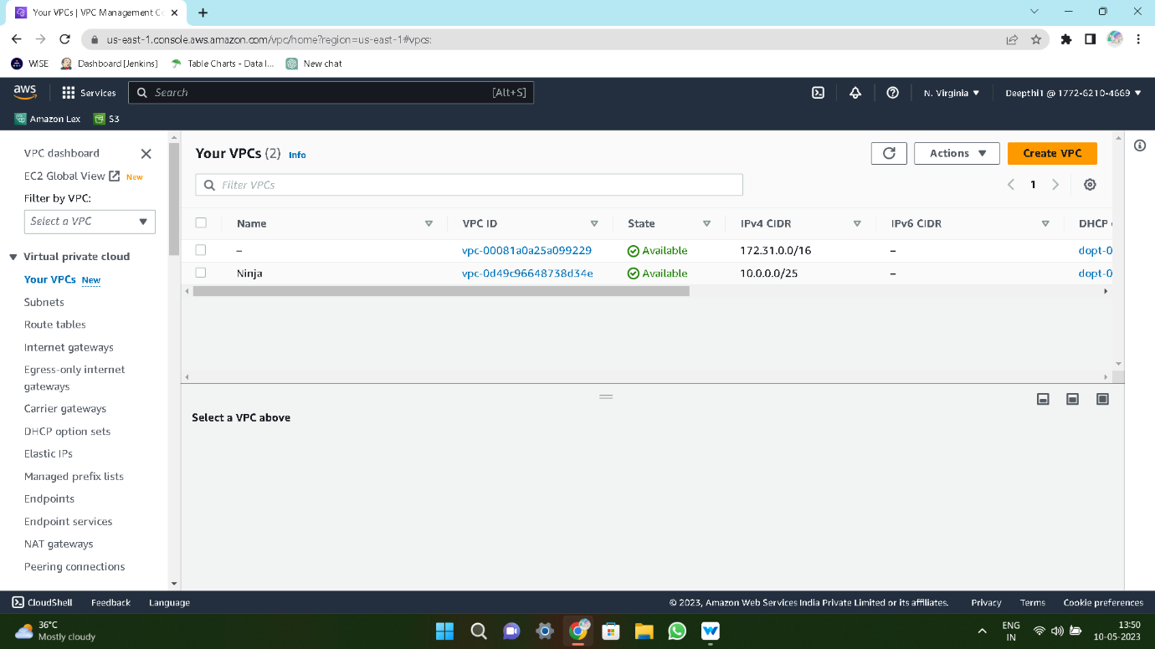

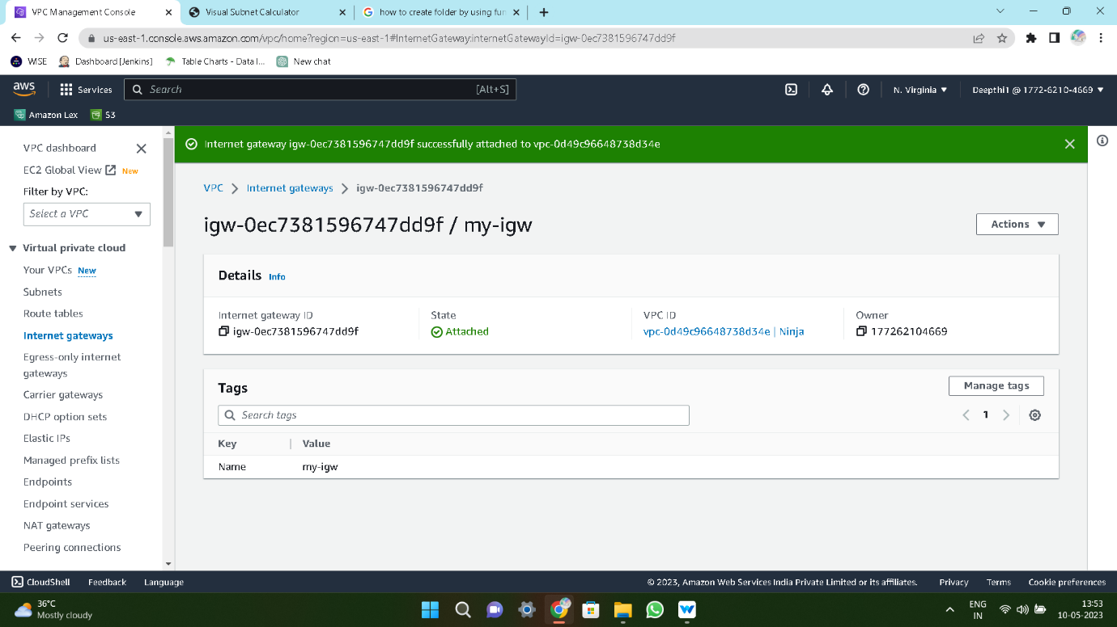

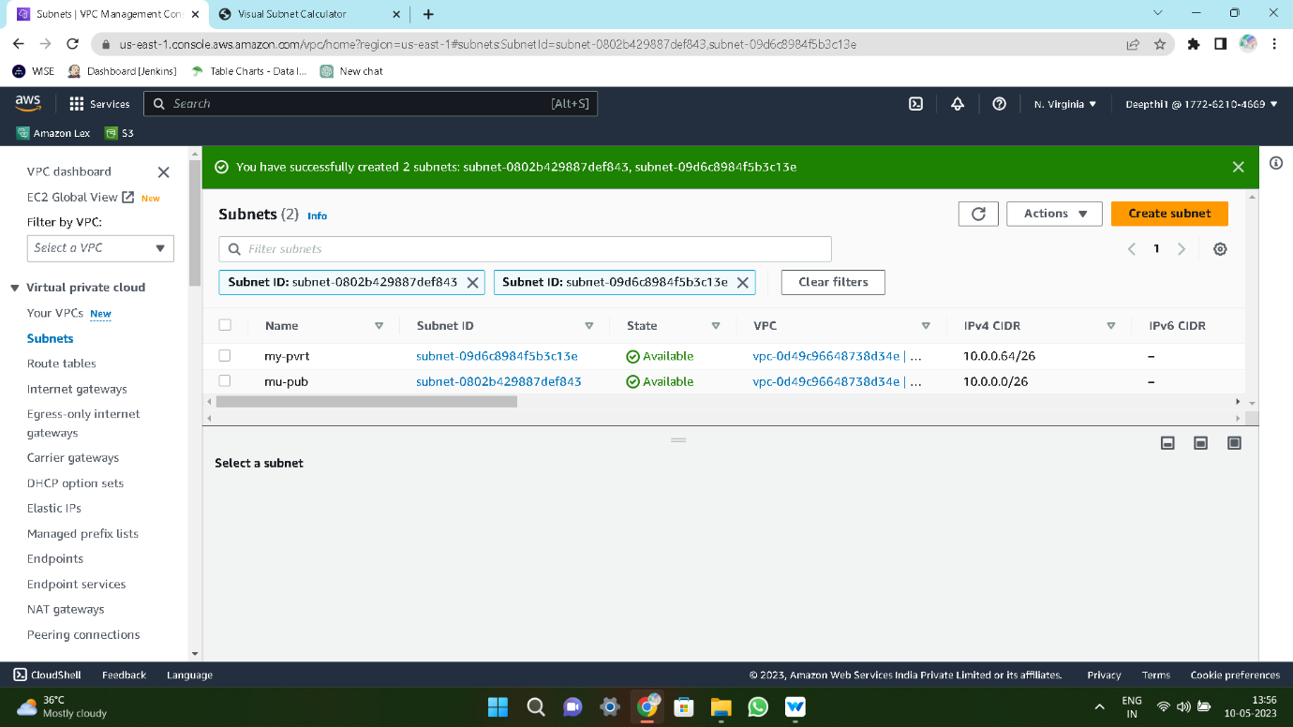

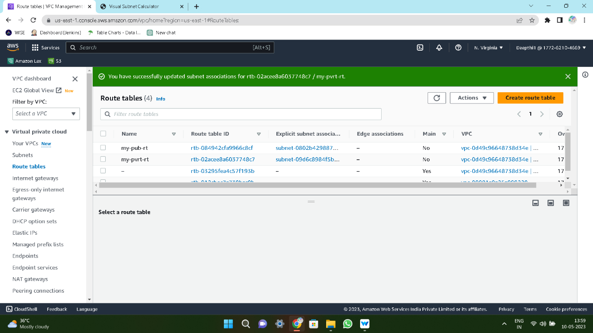

Step-2: Creating **Public** and **Private**

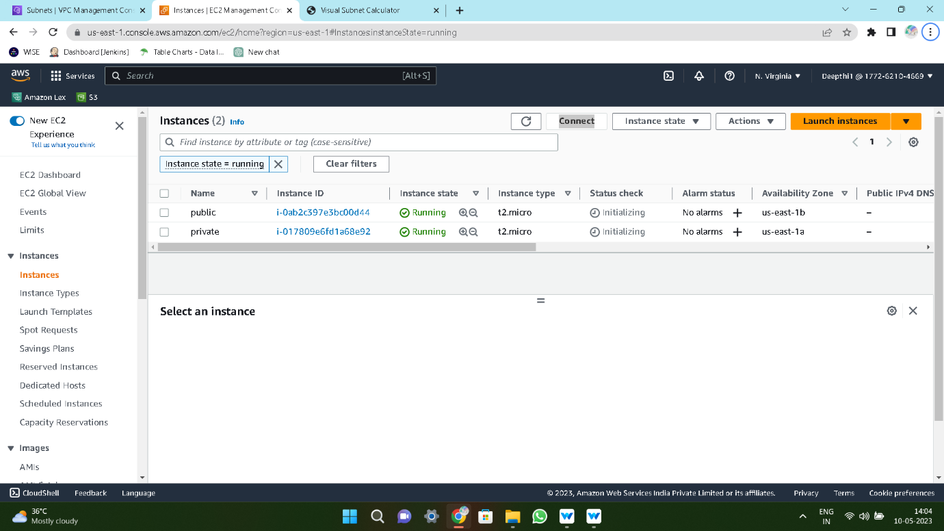

Step-3: Connect **Private** Instance through **Public** Instance by using **NAT Gateway**

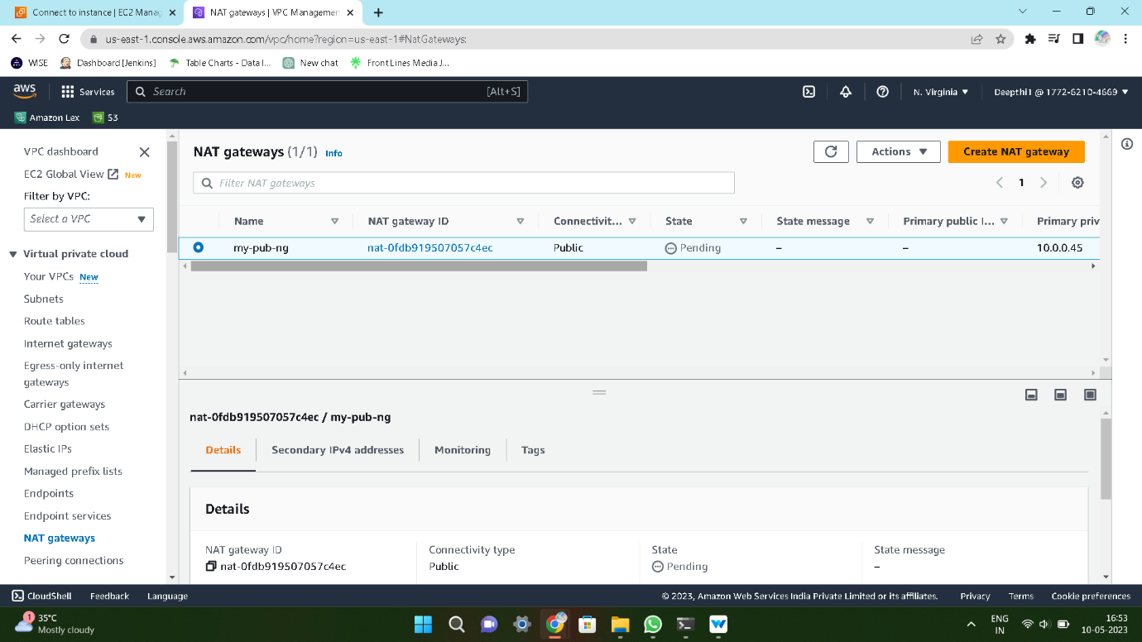

Step-4: Install **WordPress** on **Public** Instance

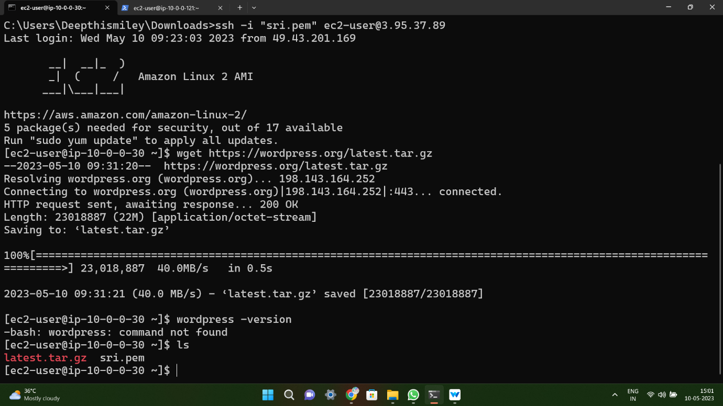

Step-5: Install **HTML** and Config **WordPress** files into HTML root directory **path**.

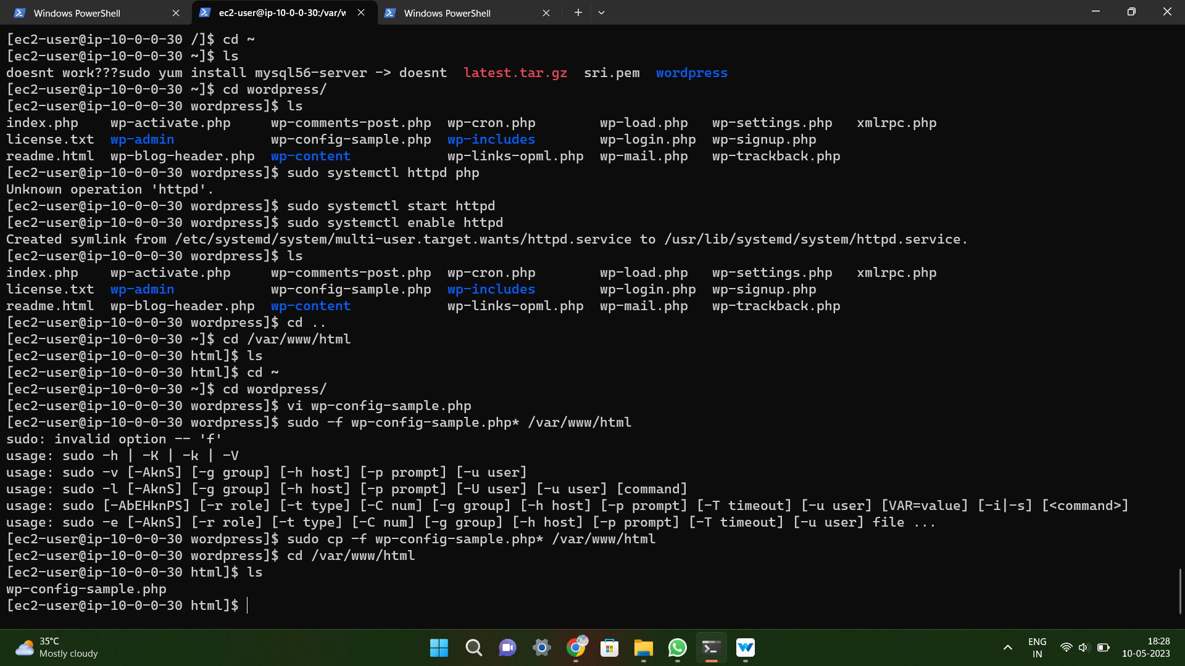

Step-6: Install **MYSQL** in private instance

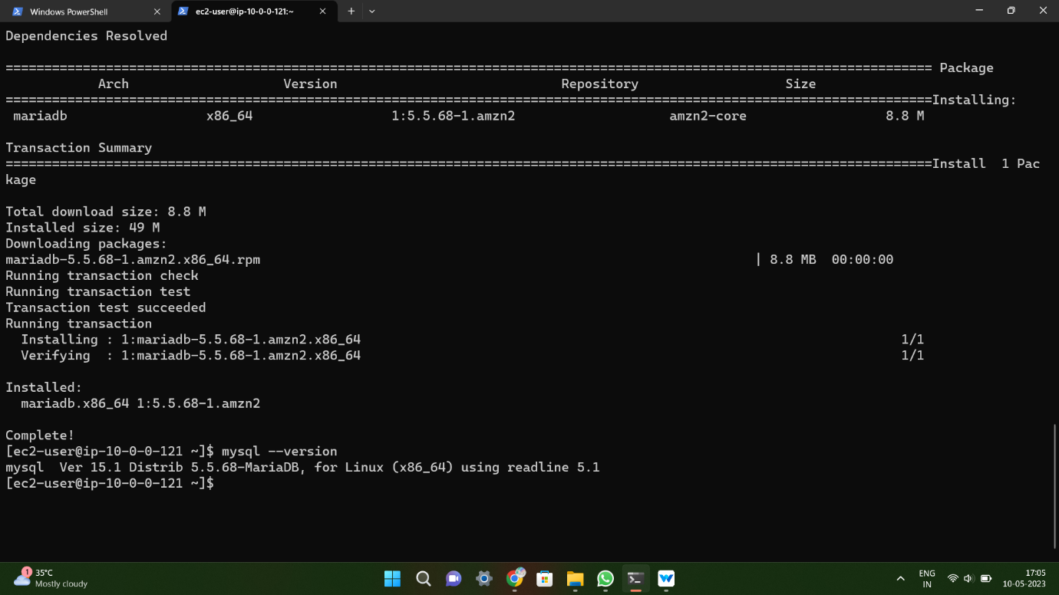

Step-7: Creating **RDS**

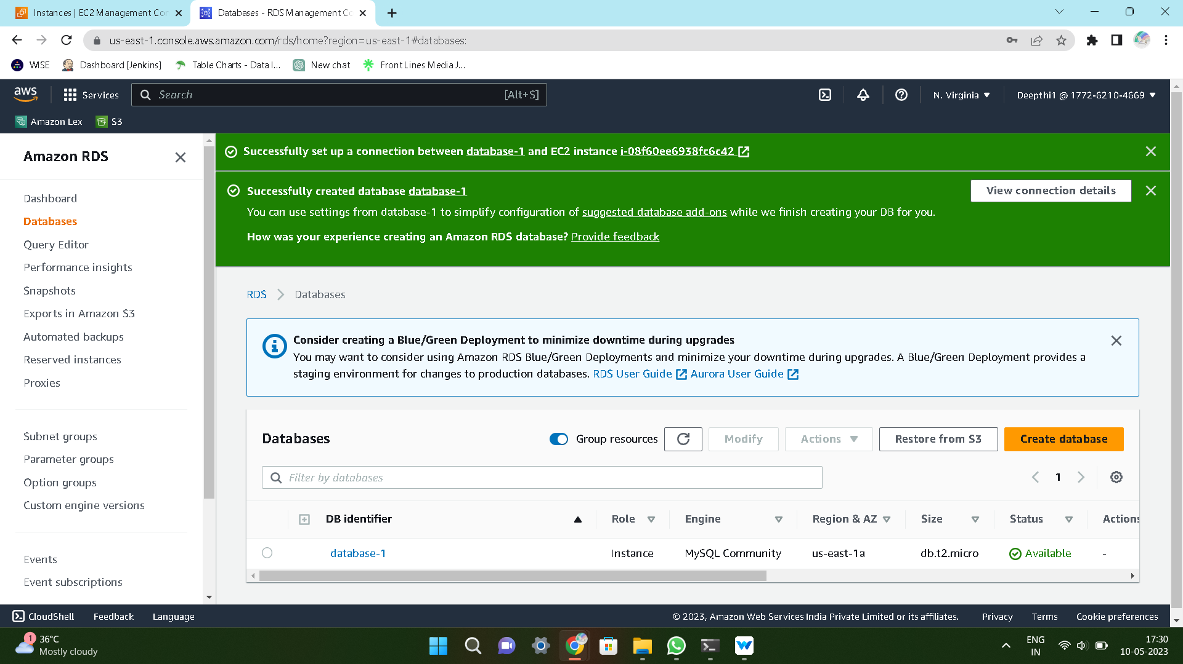

Step-8: Connecting **DATABASE** to the terminal

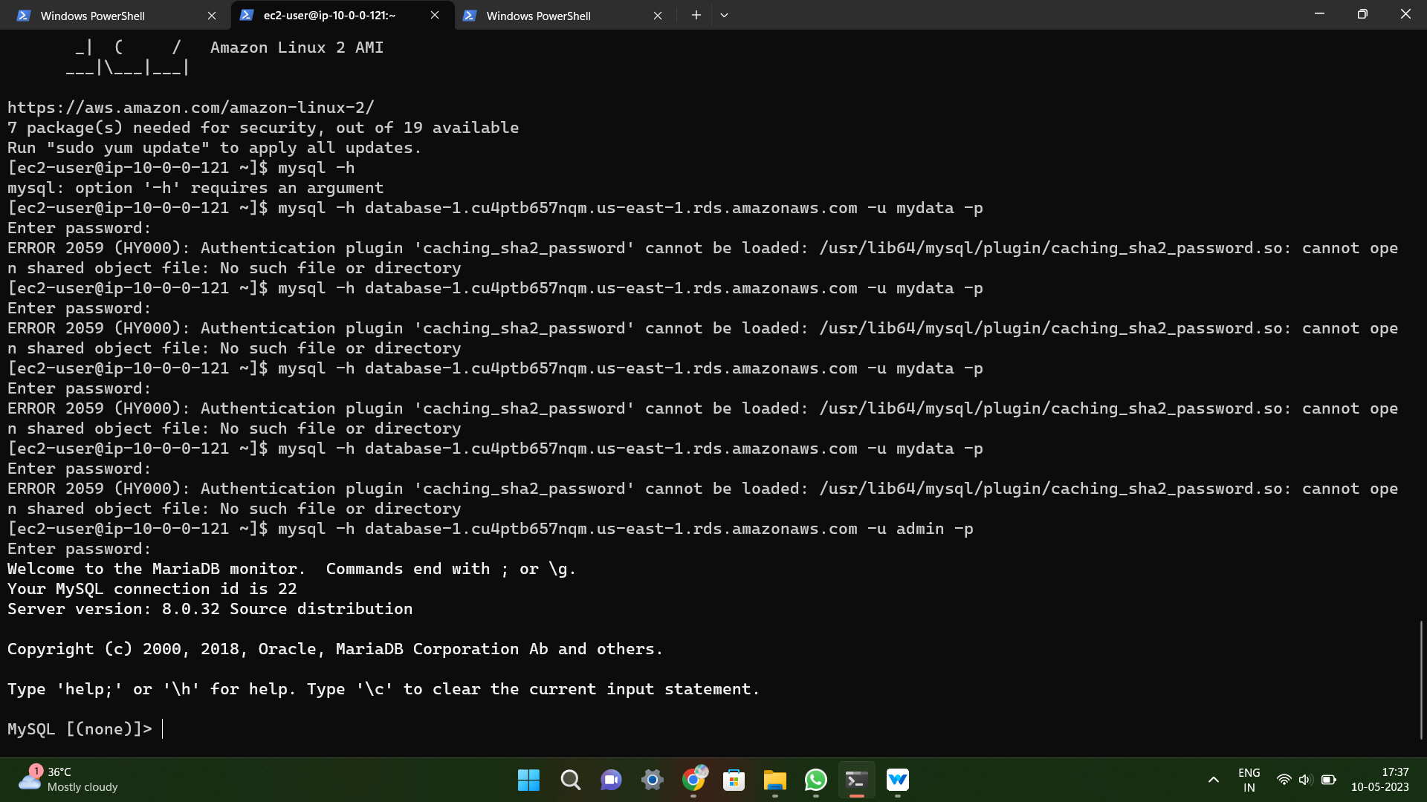

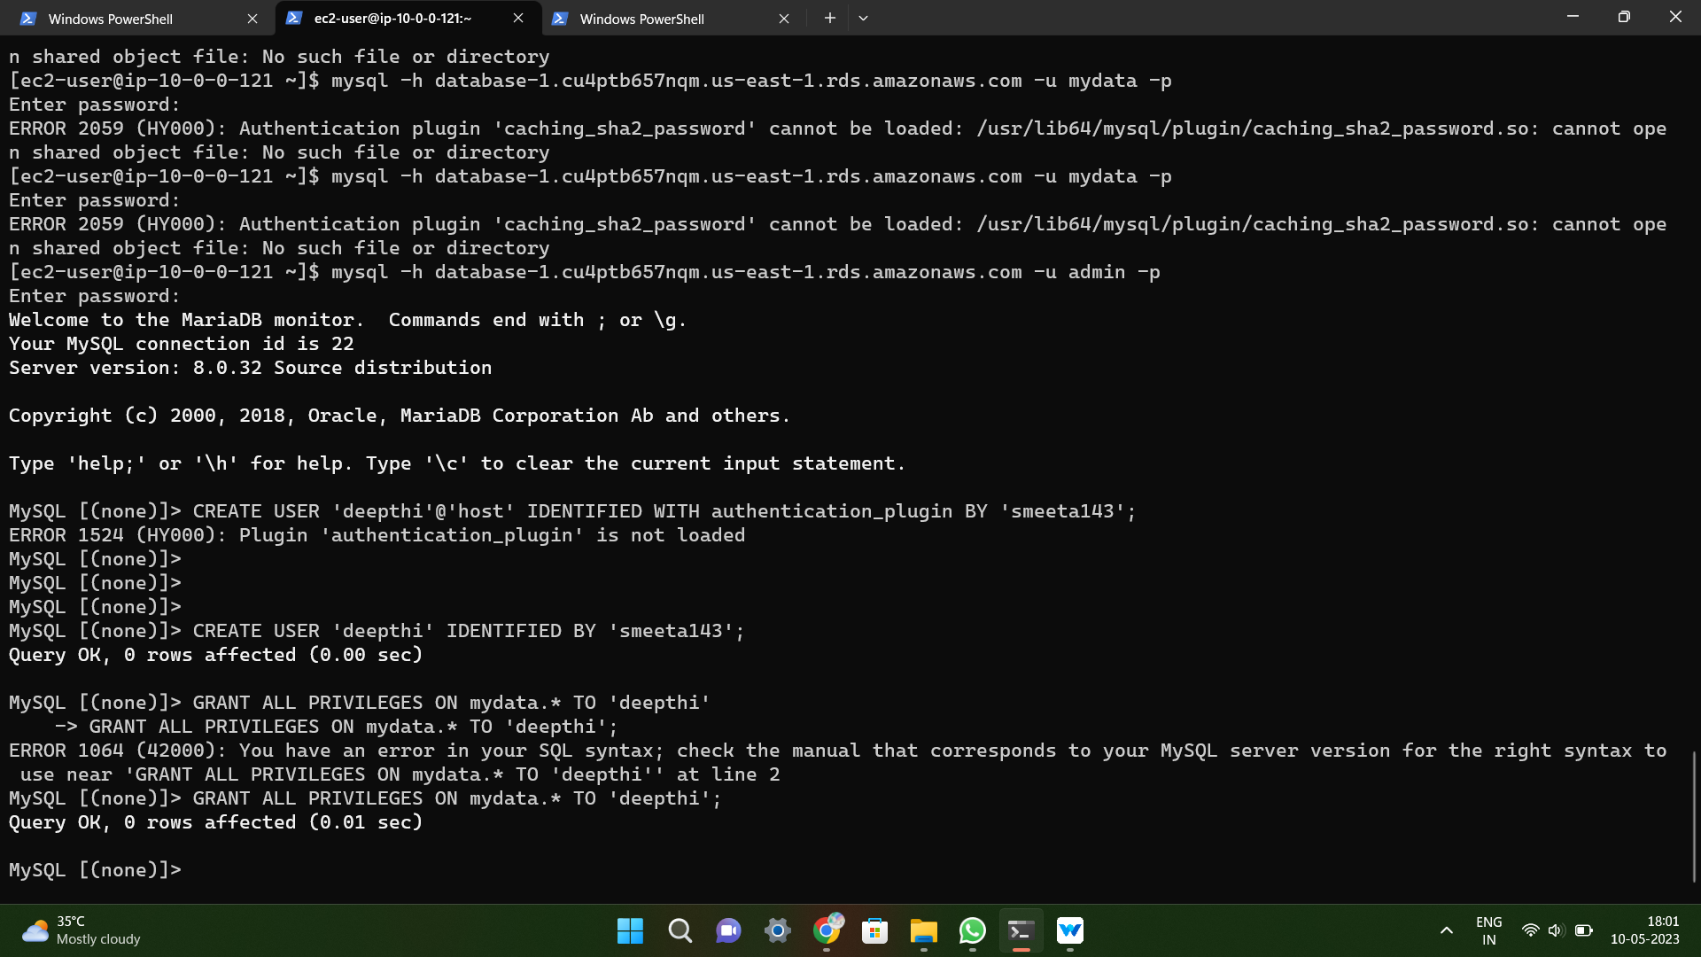

Step-9: Browsing **IP4** address and get **WordPress** application in the browser

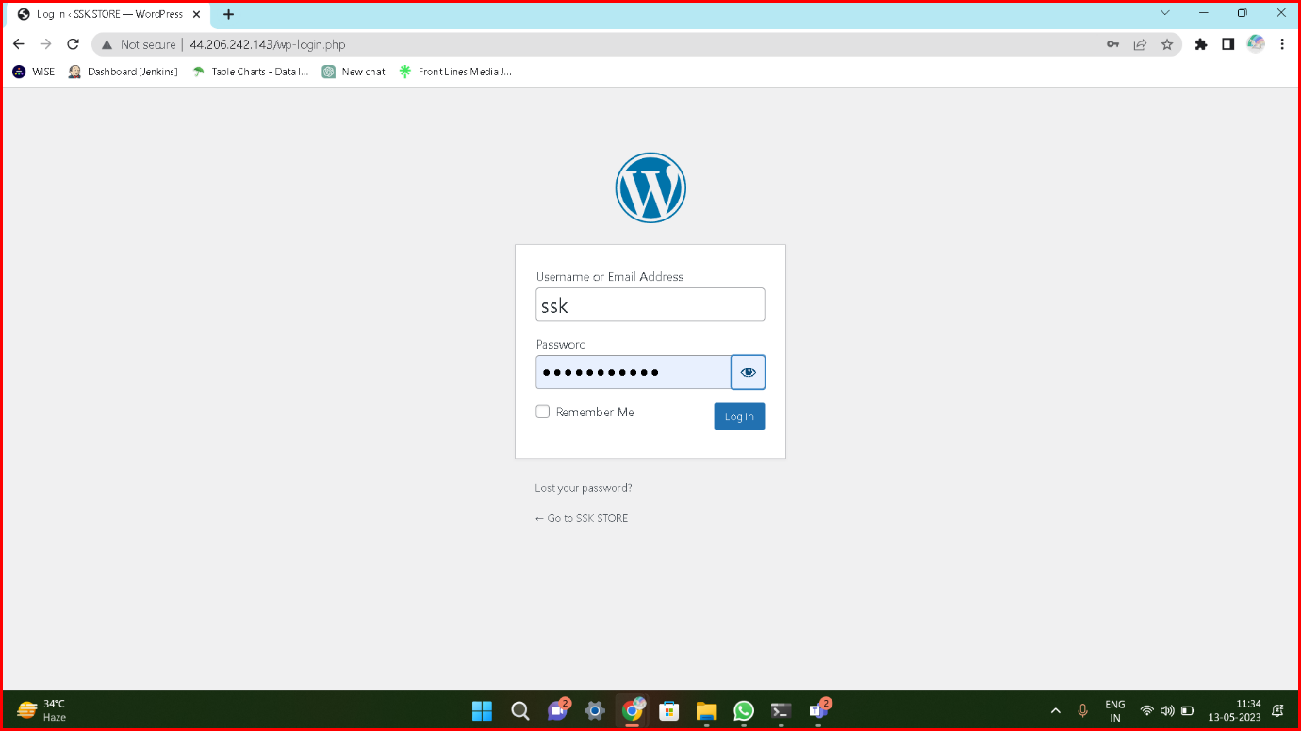

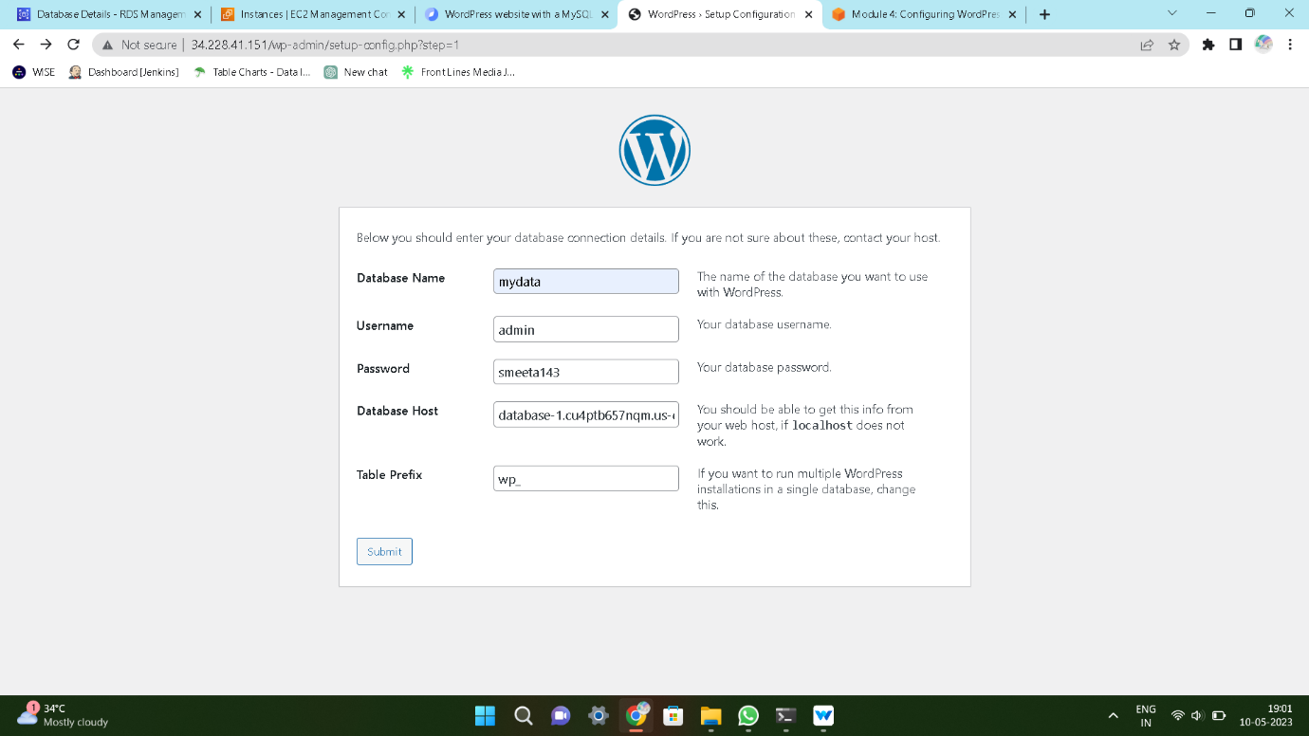

Step-10: **WordPress** page

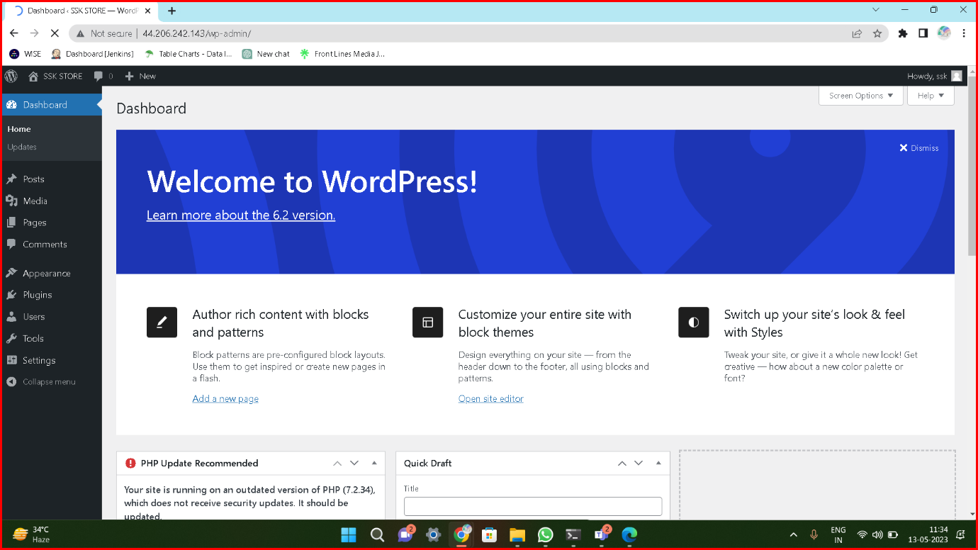

**Method-2:**

**Deploying WordPress by using Jenkins**

Step-1: Create an **EC2** instance and connect to the **Terminal**

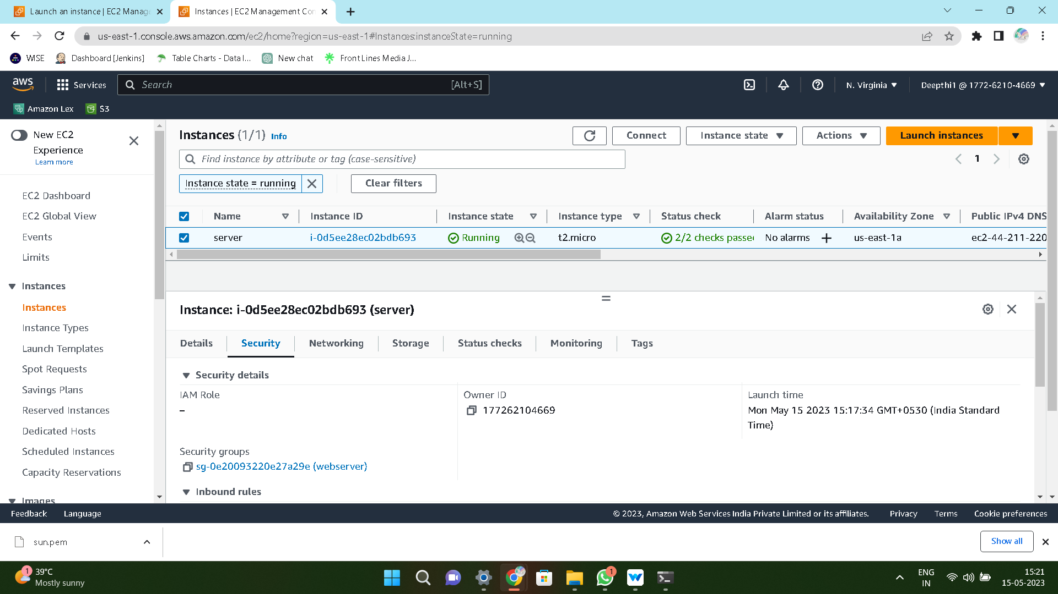

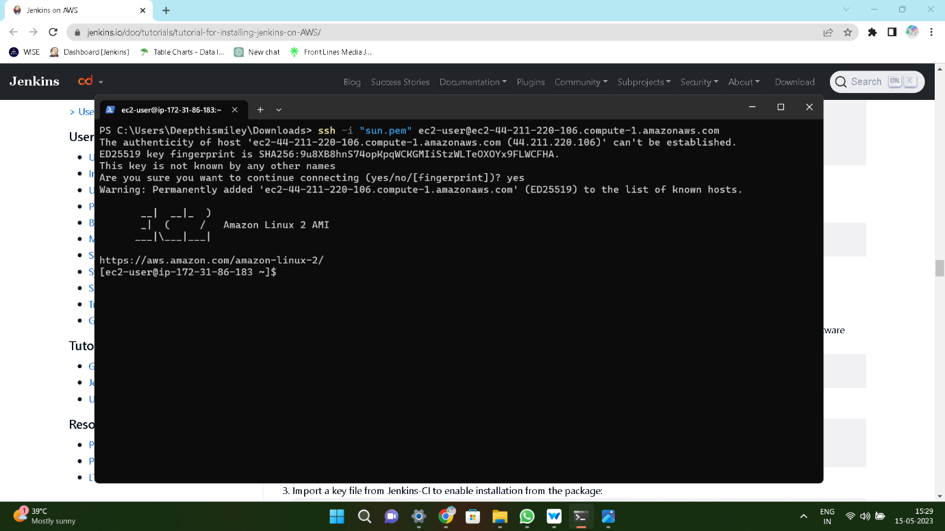

Step-2: Install **Jenkins** server and **Start** & **Enable** that server

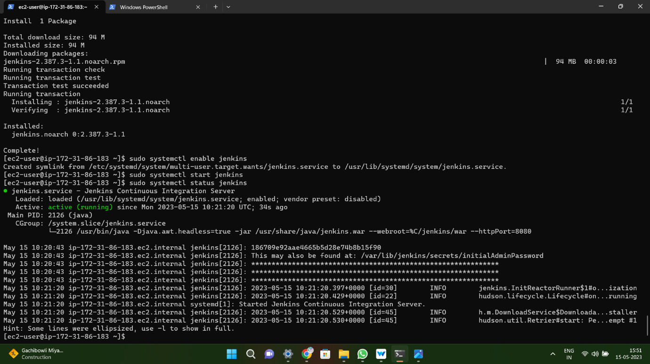

Step-3: Browsing IP4 address and paste it and add some plugins and login Into Jenkins home

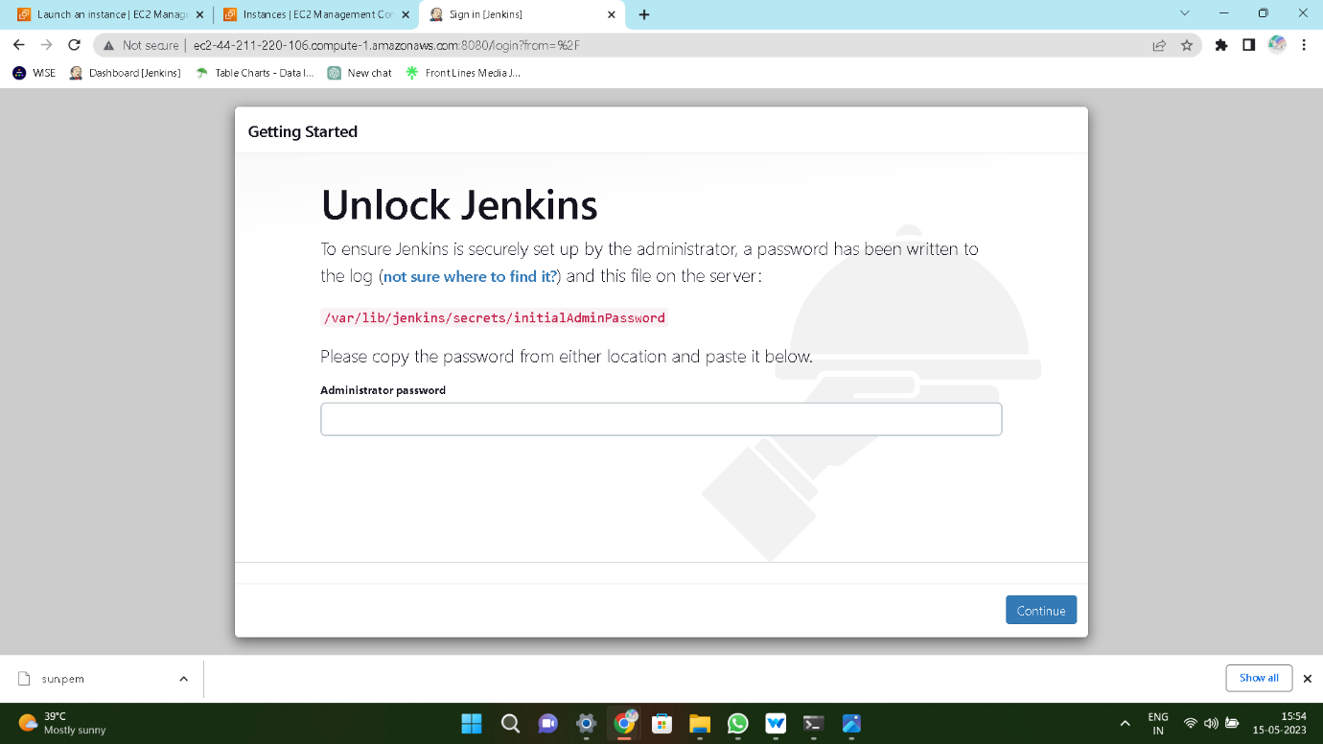

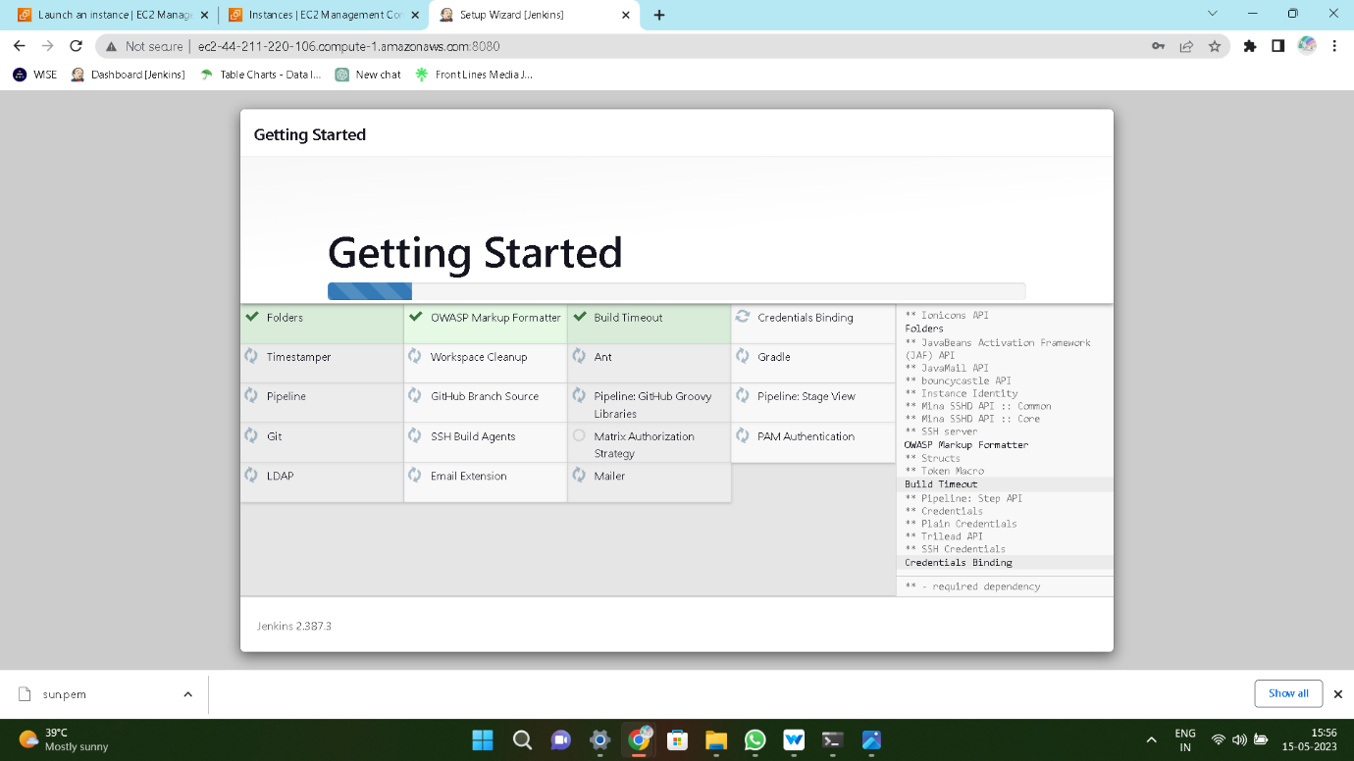

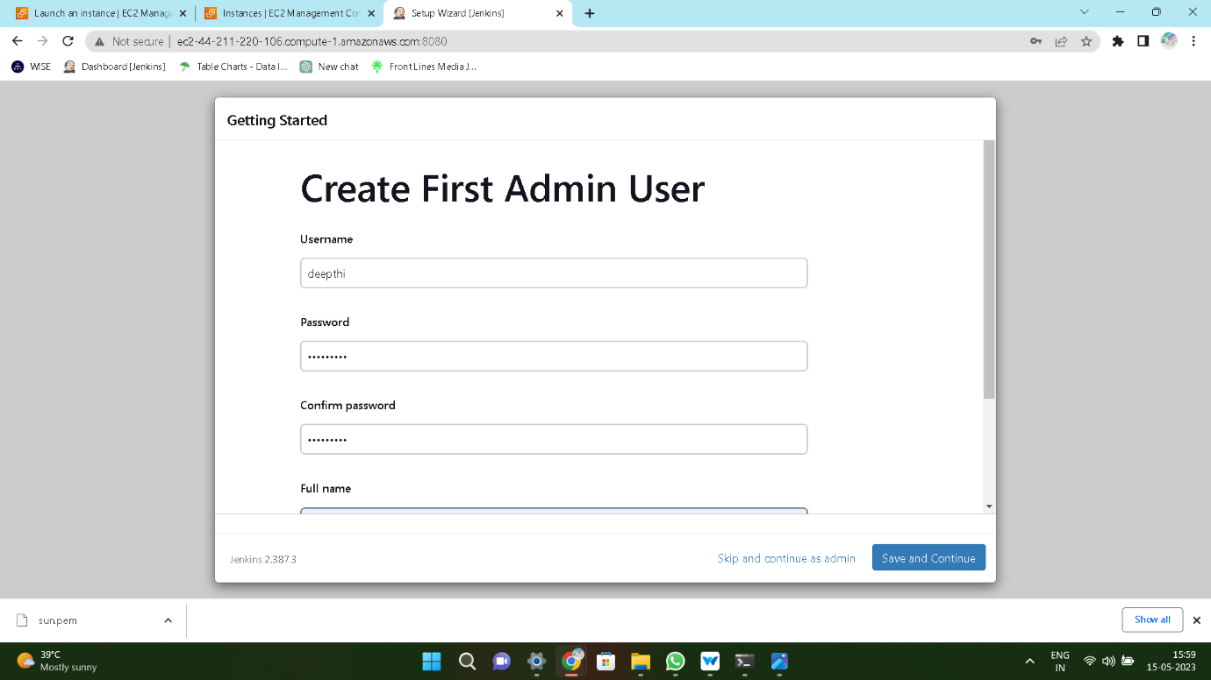

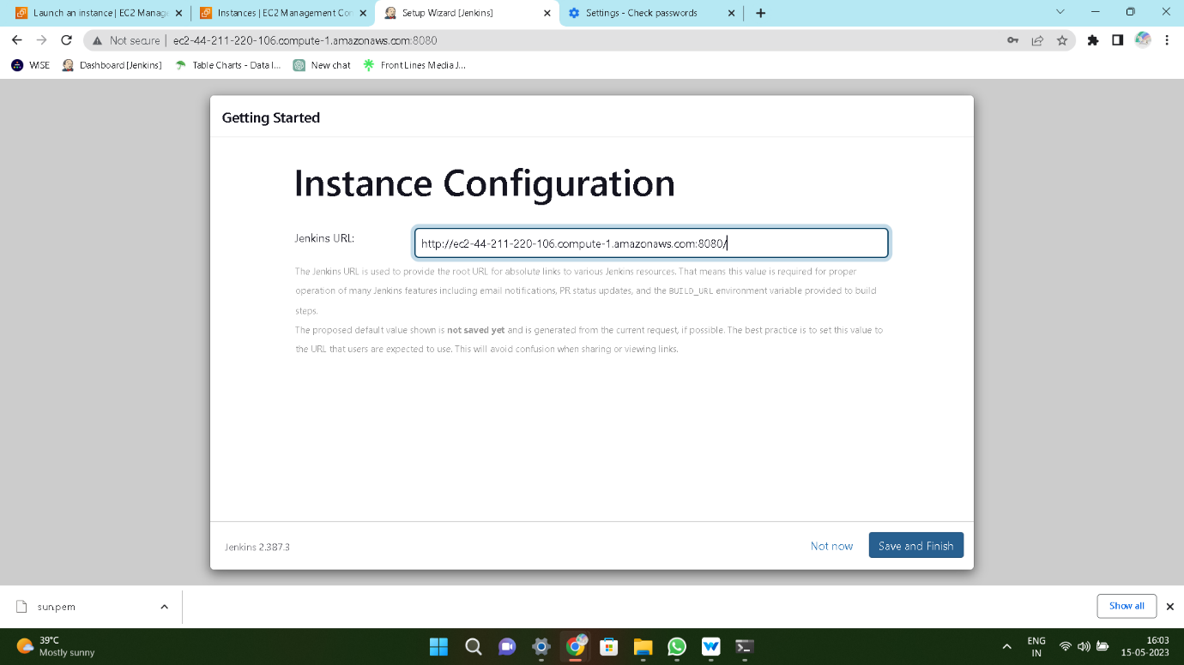

Step-4: Give the **userdata** in the **Execute shell** and build it.

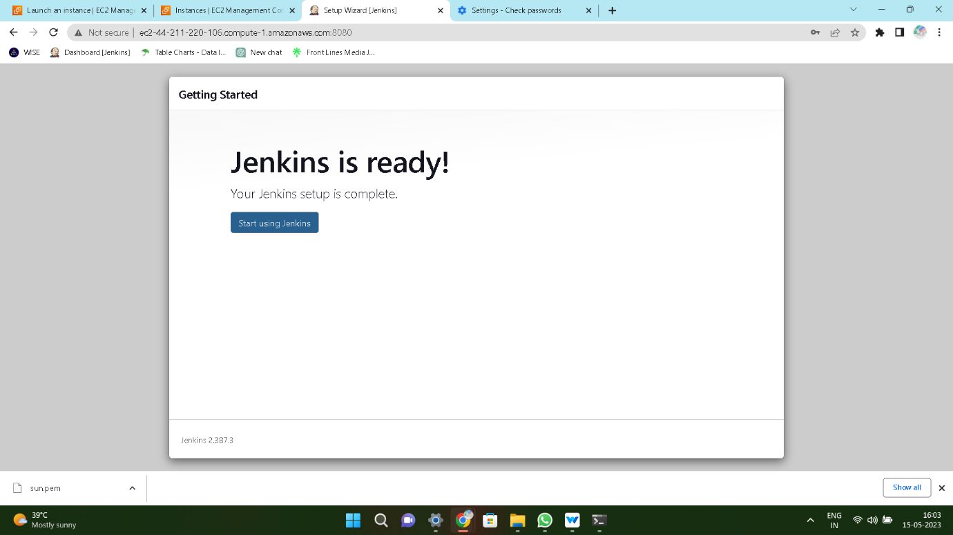

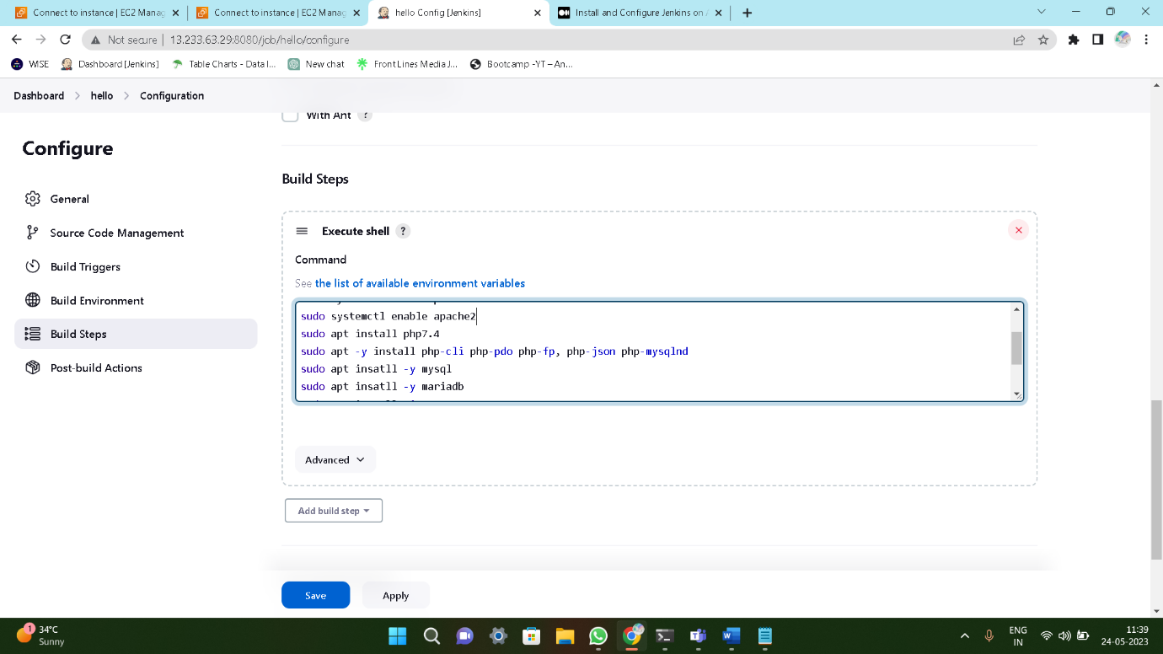

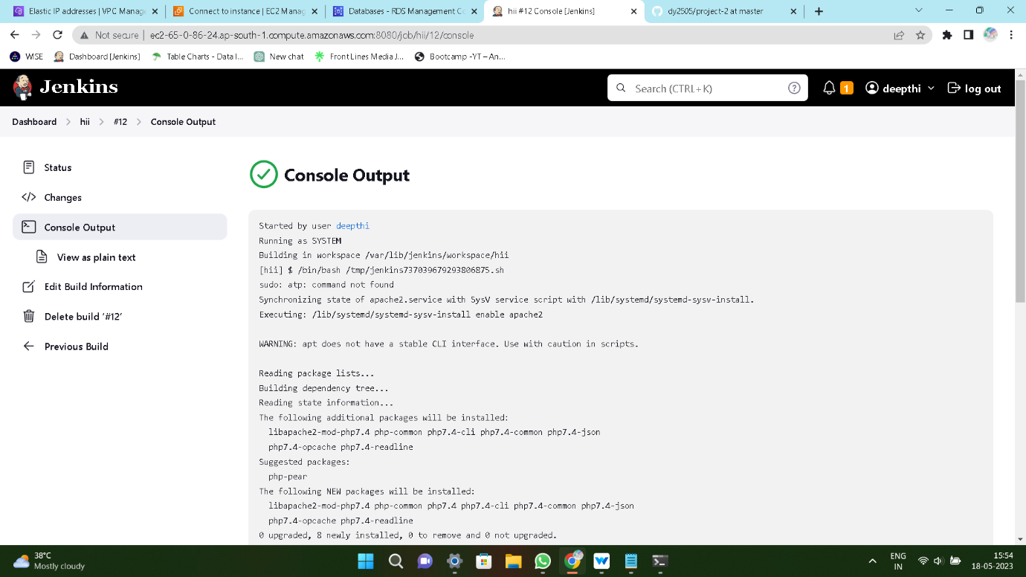

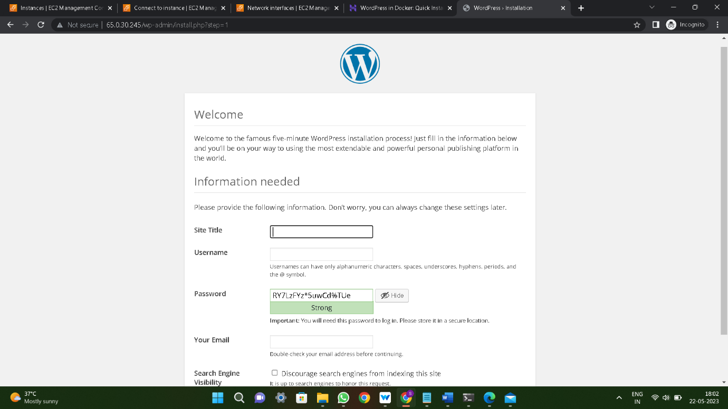

**Method-3:**

**Deploying WordPress by using Docker Image**

Step-1: Create an **EC2** instance

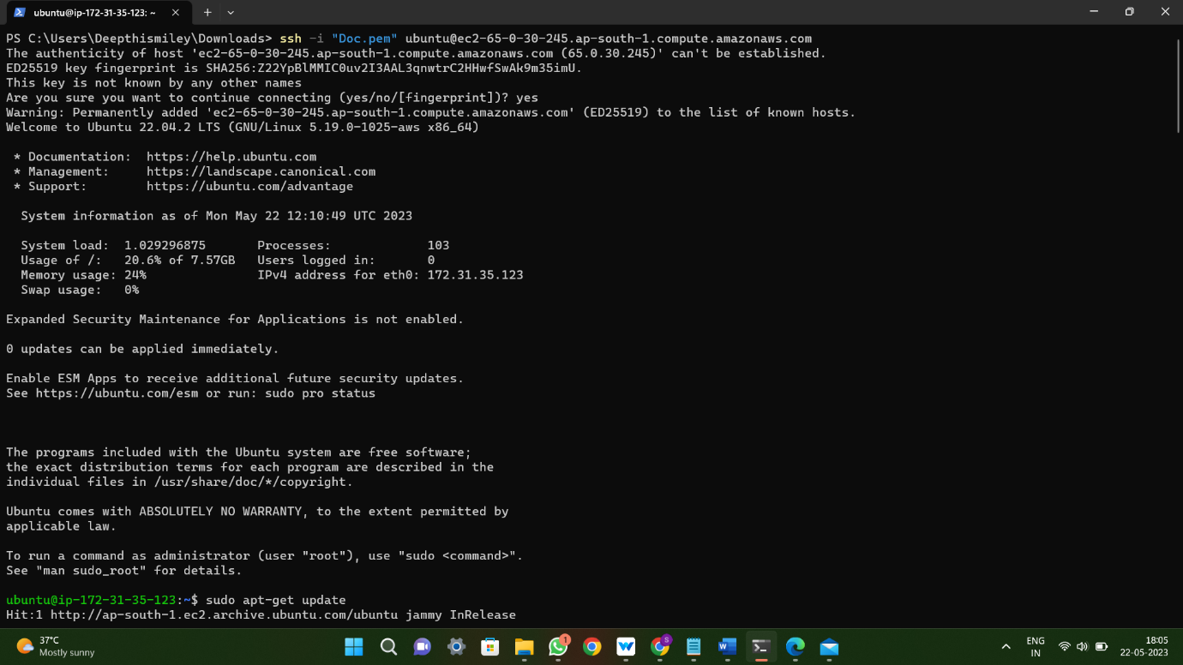

Step-2: Install **Docker** and give execute permission and **start** and **enable** the service

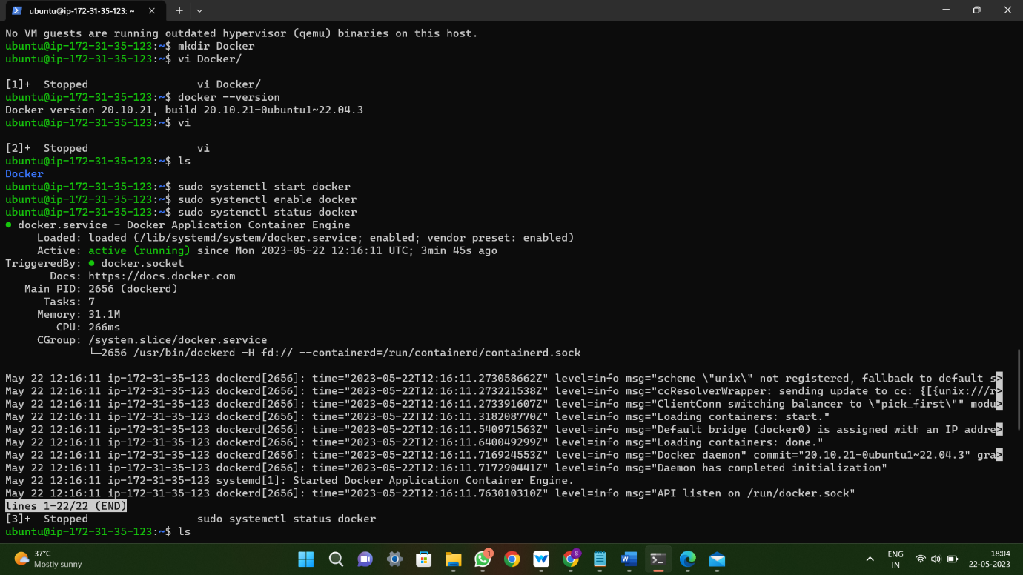

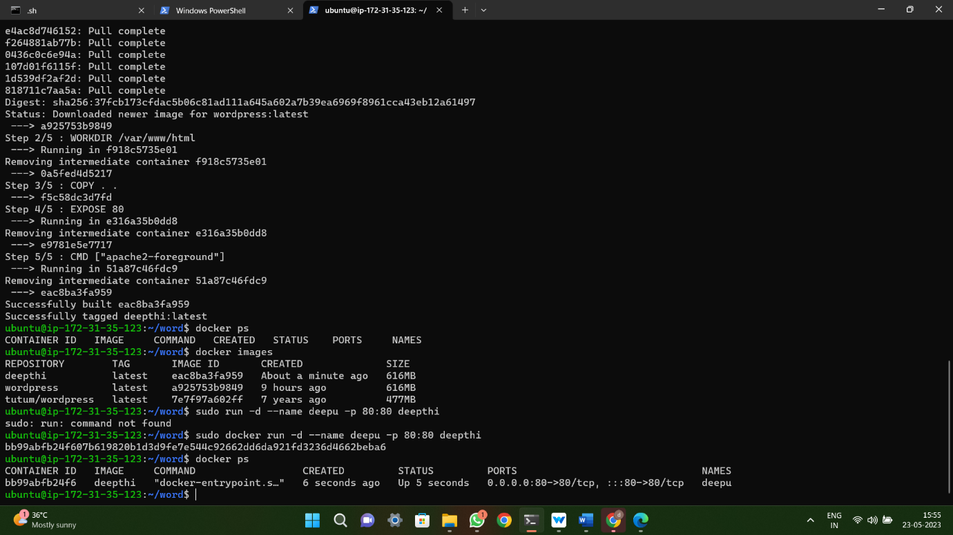

Step-3: Output of the **WordPress**

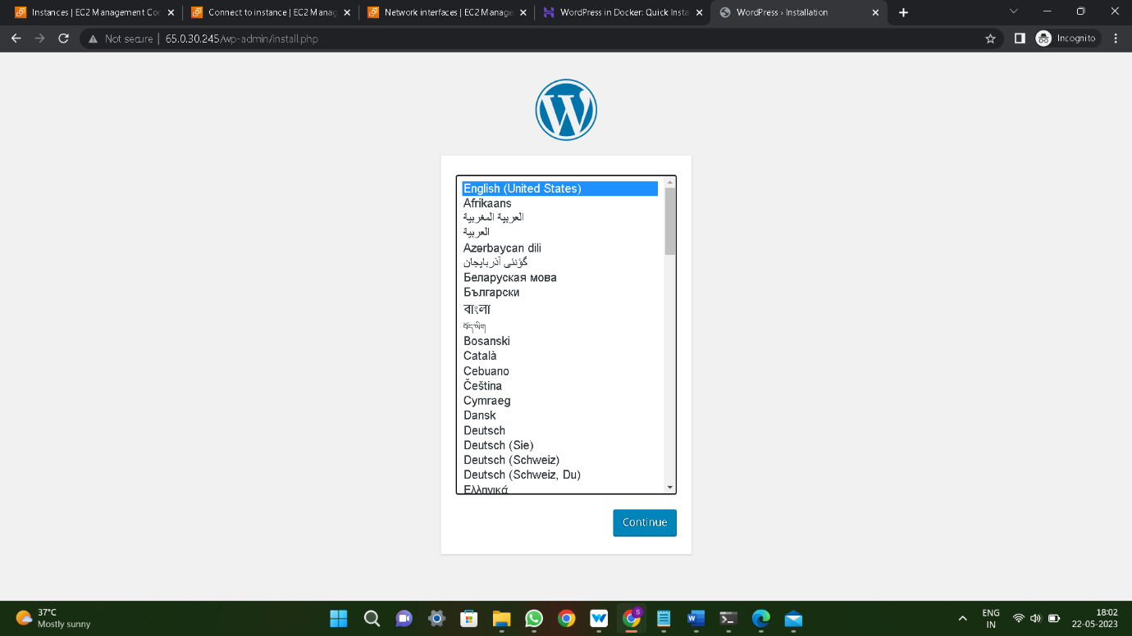



**Method-4:**

**Deploying WordPress by using Docker-Compose**

Step-1:Create an **EC2** instance

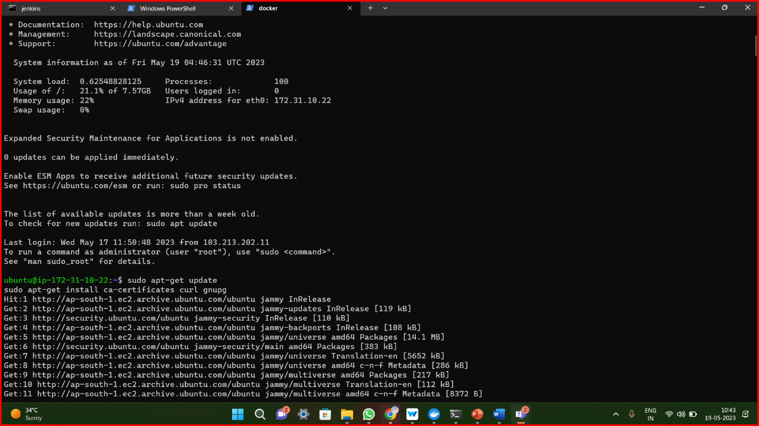

Step-2: Install **Docker** and **Docker-Compose** give execute permission and **start** and **enable** the service and pull the **WordPress** Image into **Docker-Compose**

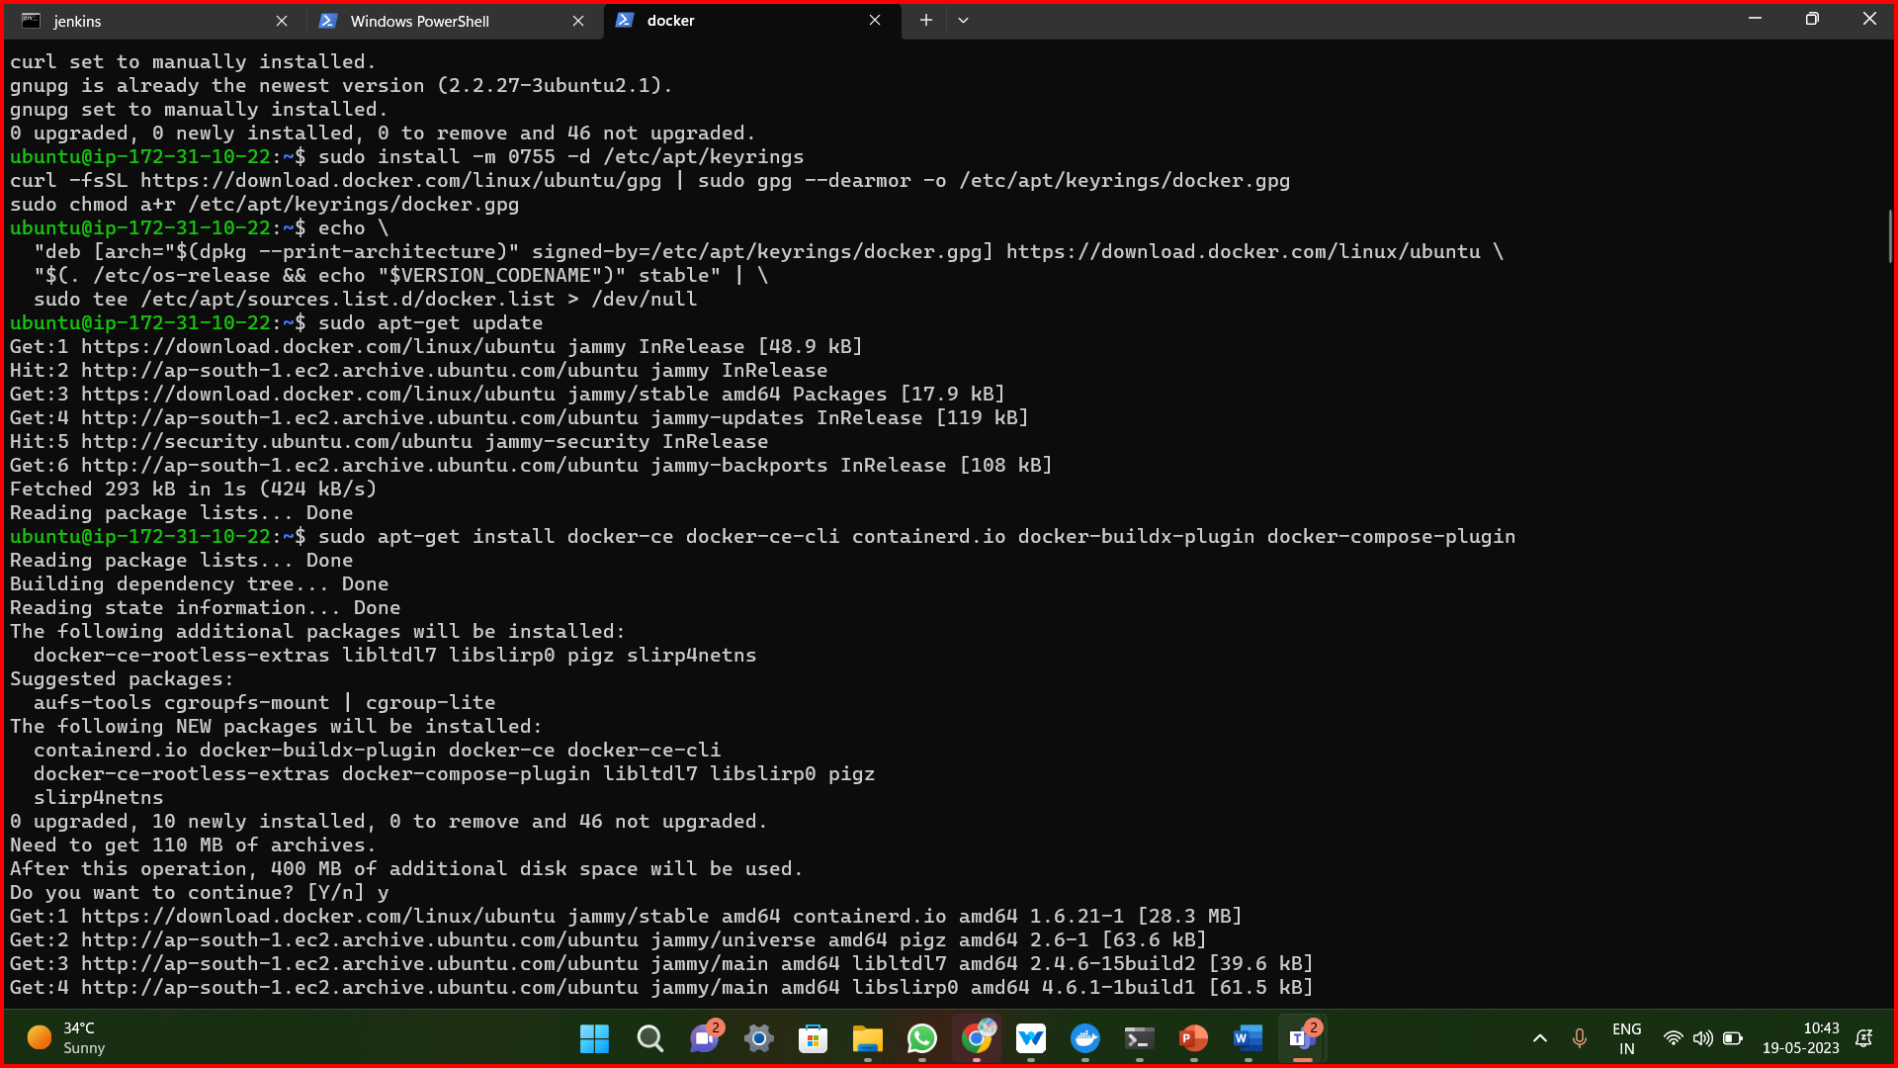

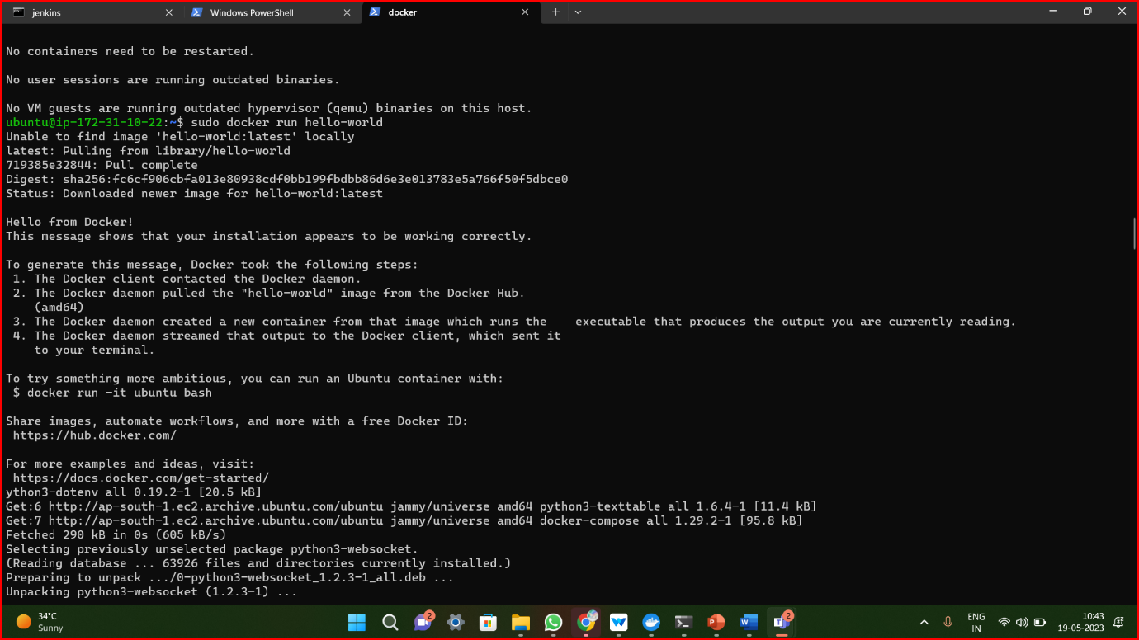

Step-3: yaml script in **docker-compose**

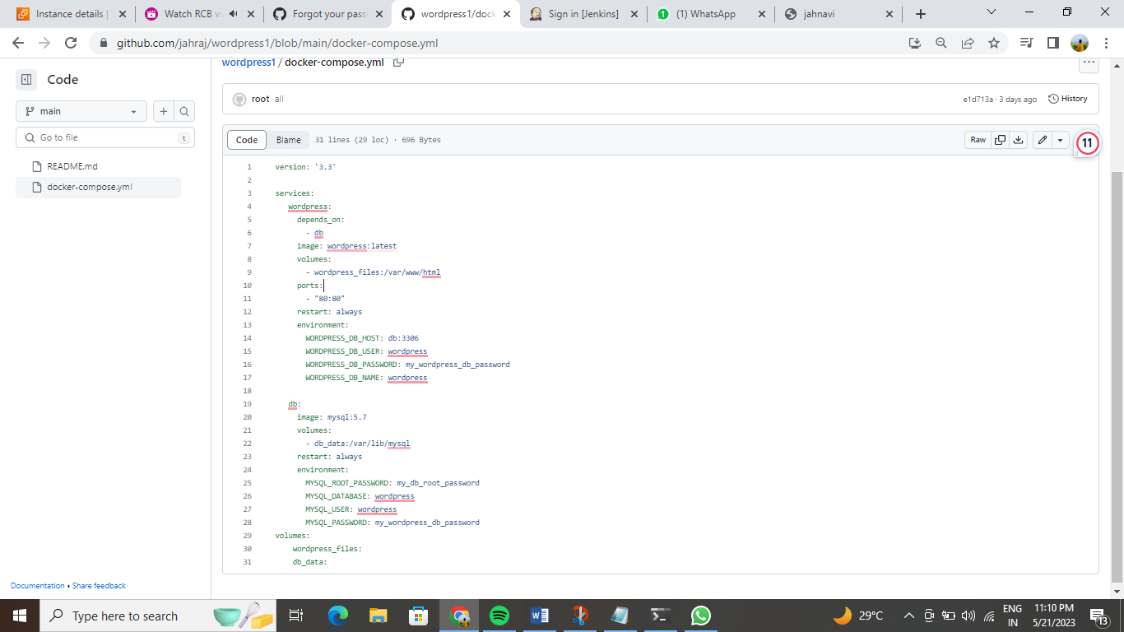

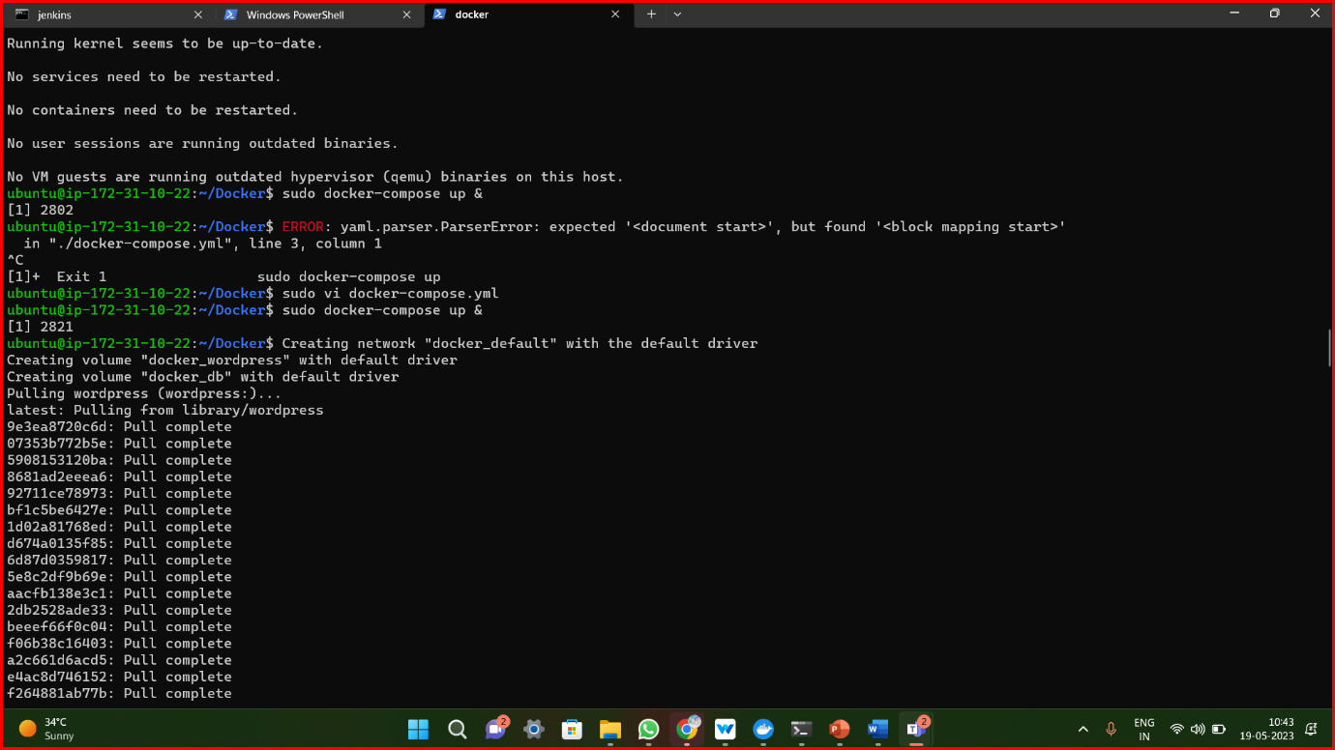

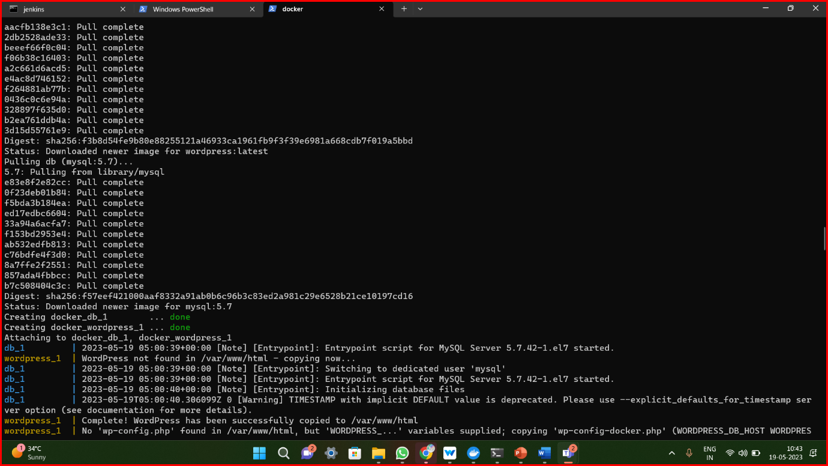

Step-4: Final output is **WordPress**

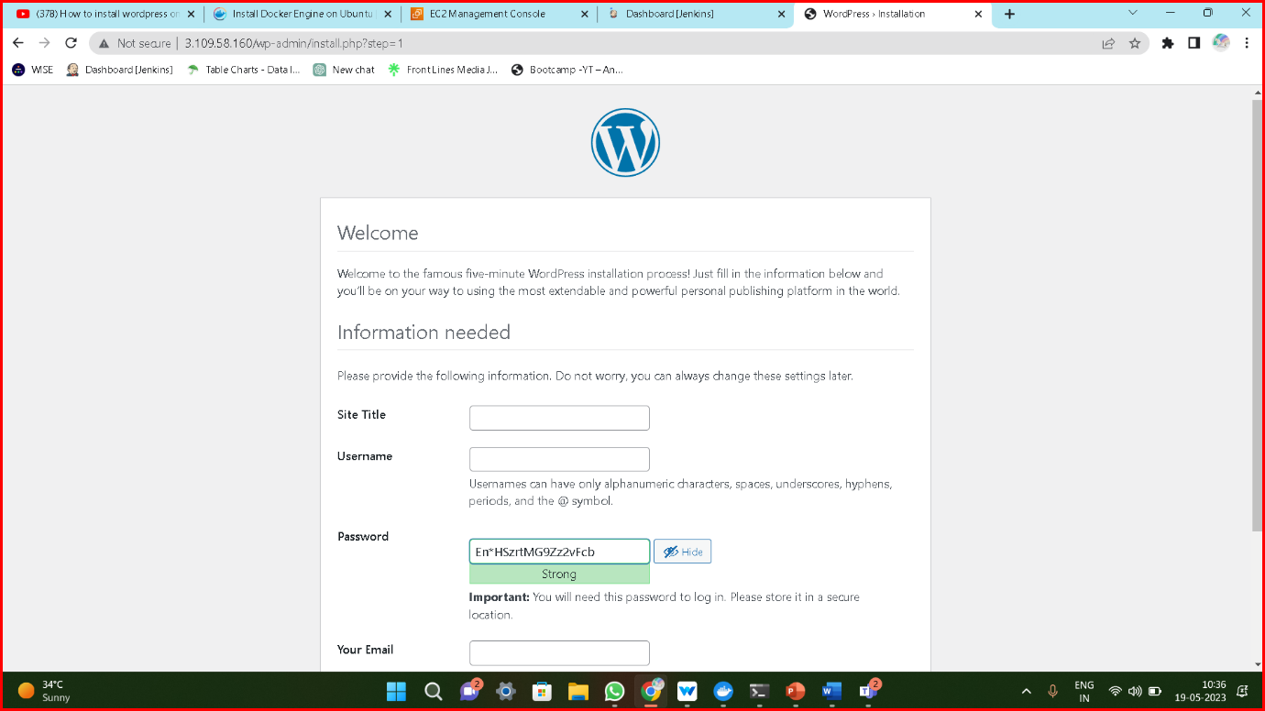

**Method-5:**

**Deploying WordPress by using Userdata.sh**

Step-1: Create an **EC2** instance and add script in **Userdata**.sh

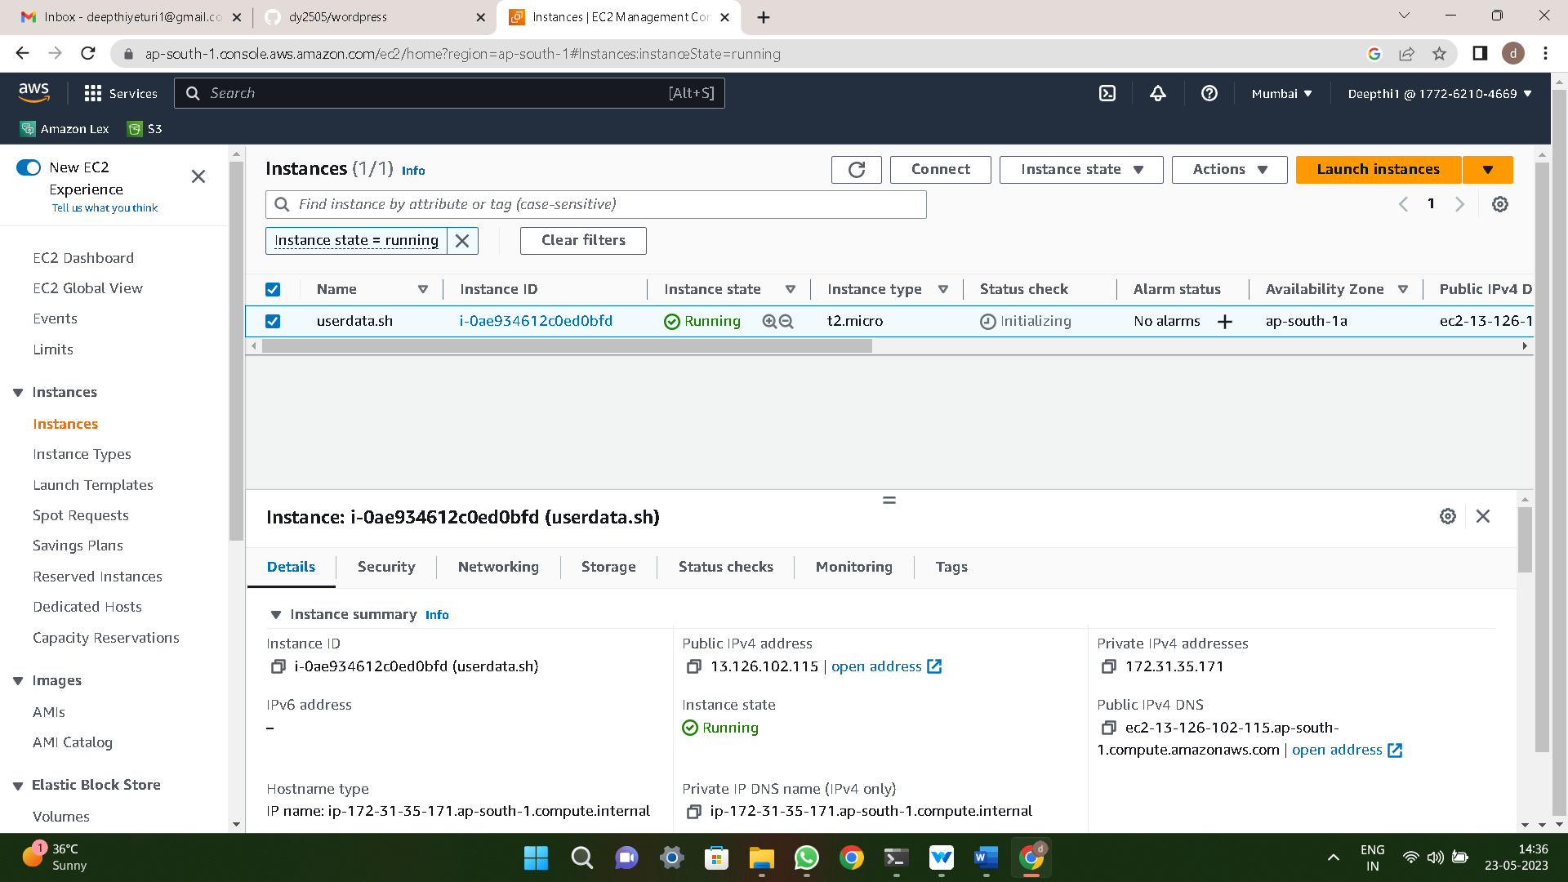

Step-2: Connect the instance to terminal and by using **touch** command create a **userdata.sh** file and give some permissions to the file

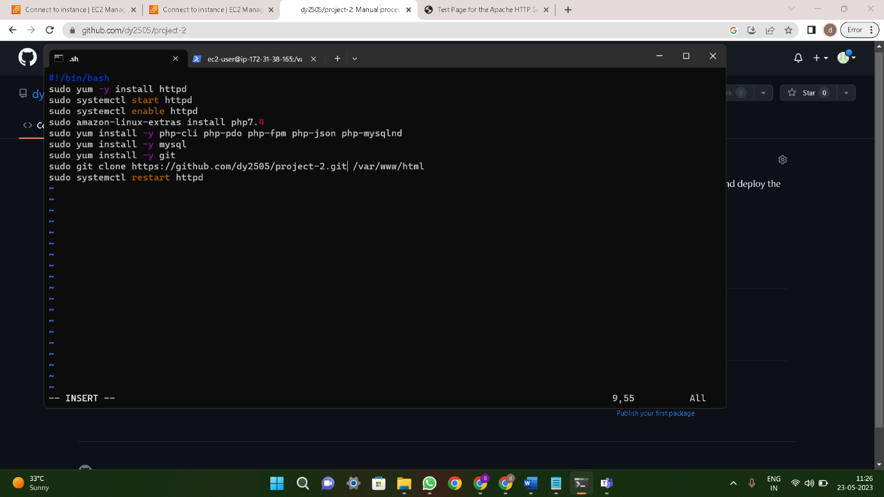

Step-3: After create **Database** give the **endpoint** in the config file

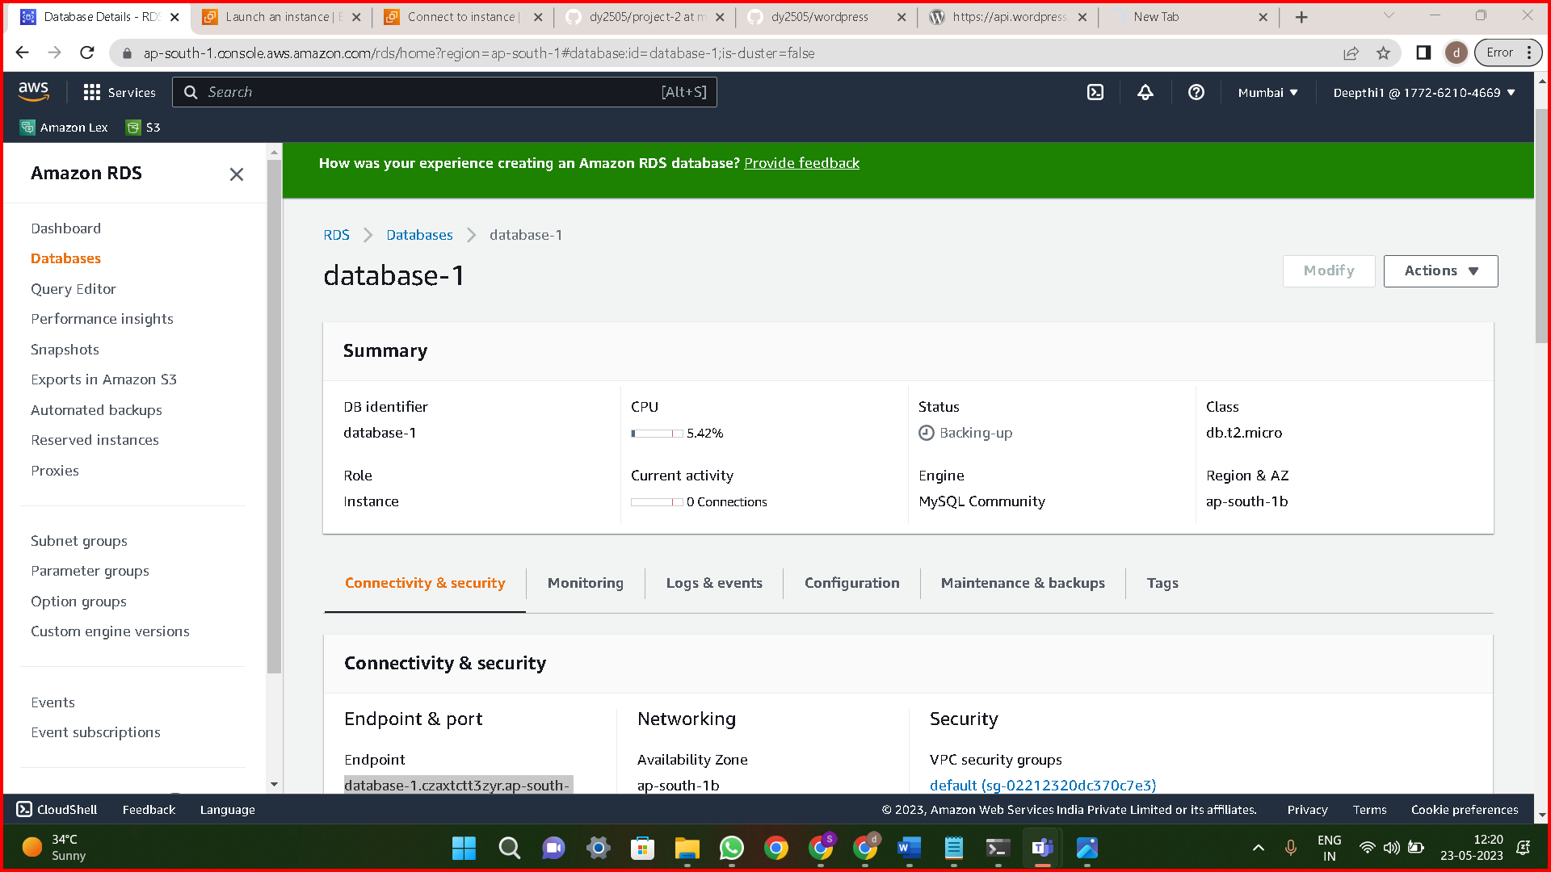

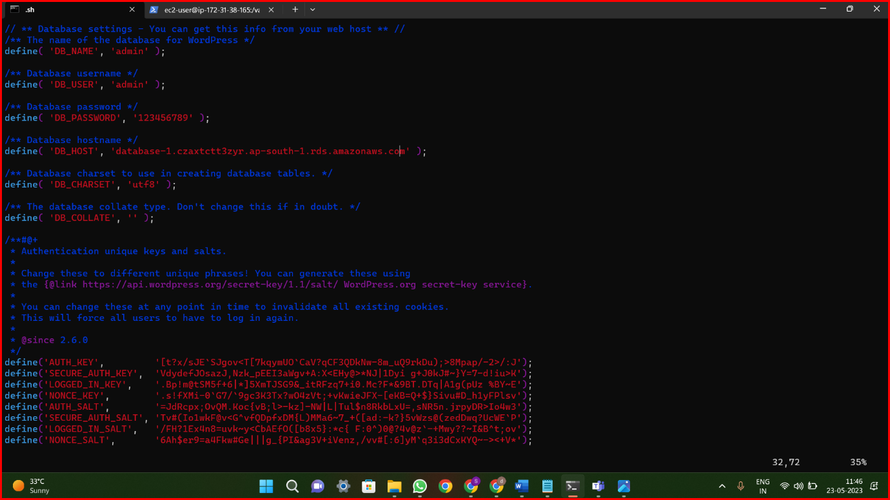

Step-4: Final output of the **userdata.sh**

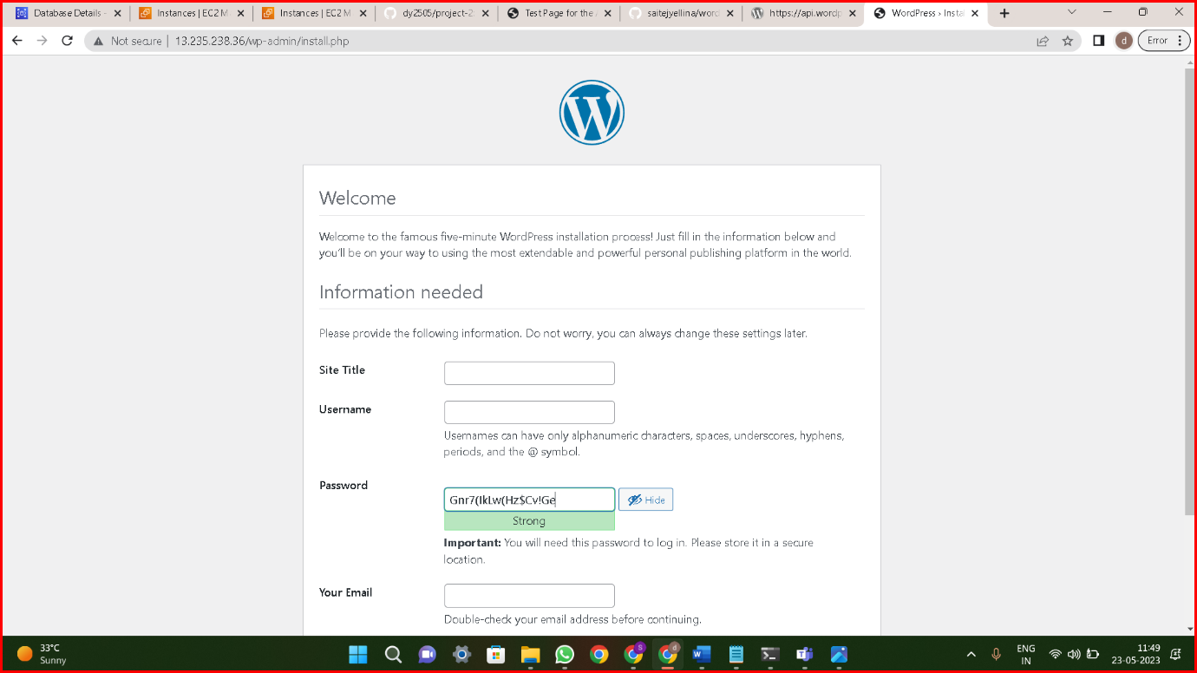

**Method-6:**

**Deploying WordPress by using Userdata**

Step-1: Create an **EC2** instance and add script in **Userdata** and give the **script** in the **userdata**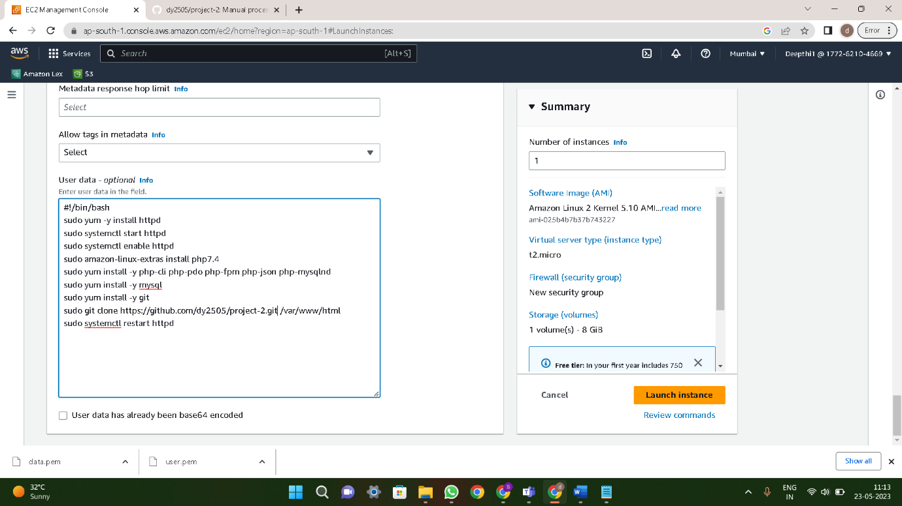

Step-2: Add Database **endpoint** and Using Public **IP4** run the data what we are given

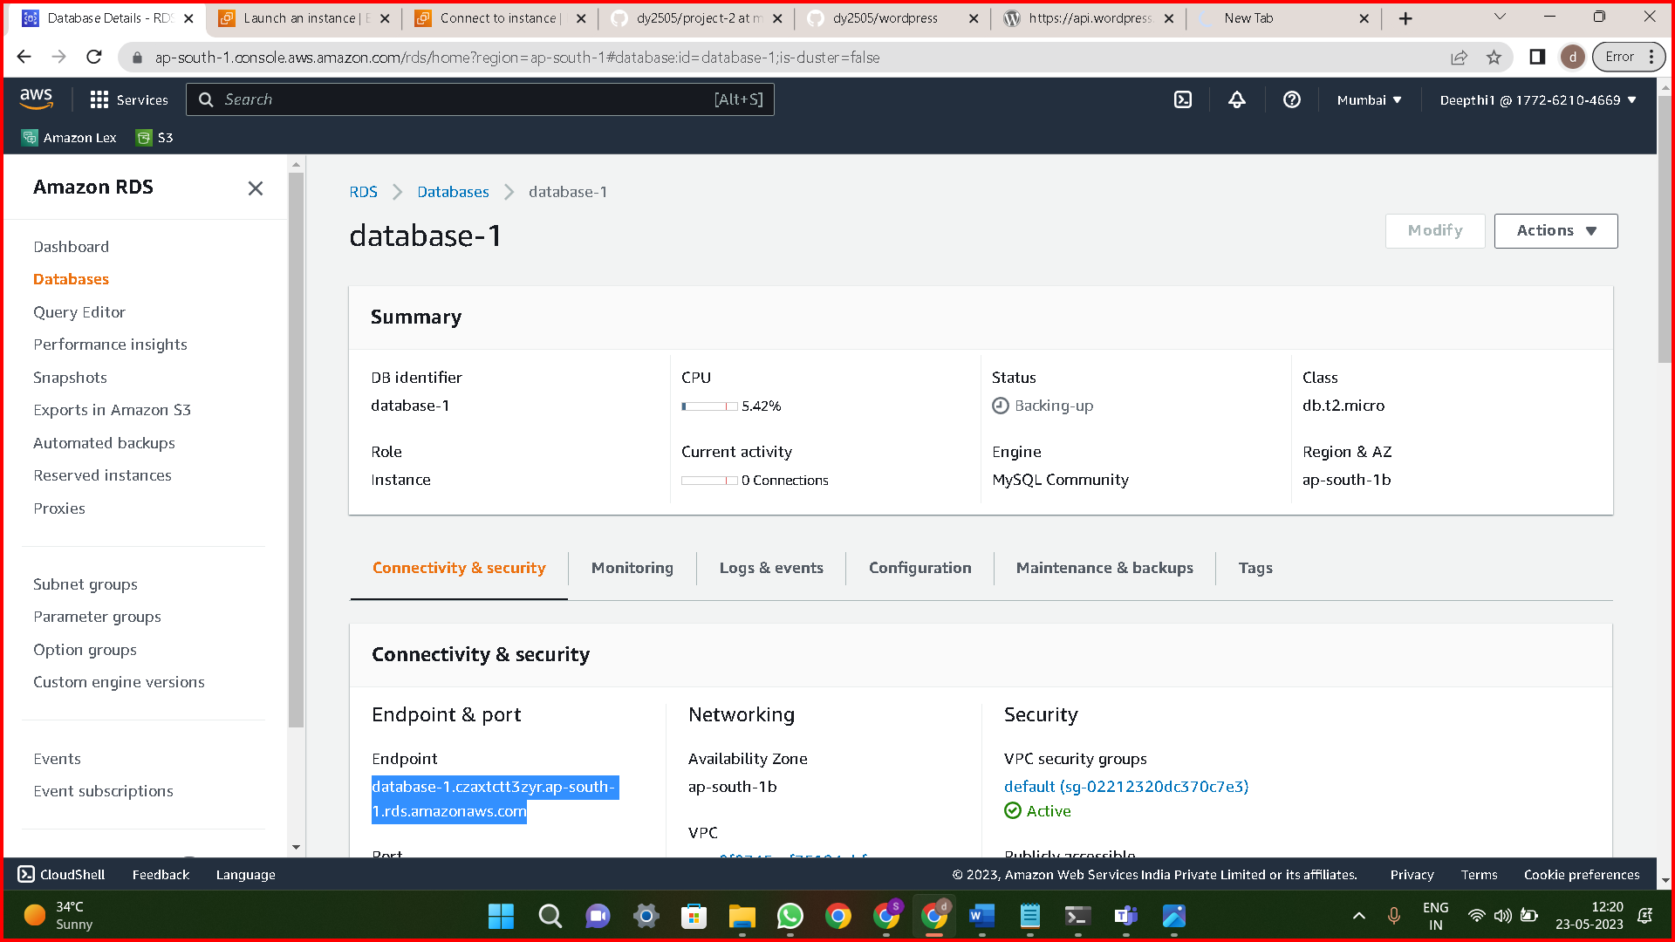



**Method-7:**

**Deploying WordPress by using Docker images & Jenkins**

Step-1: Create an Ec2 instance and connect to the terminal , Install **Jenkins** & **Docker**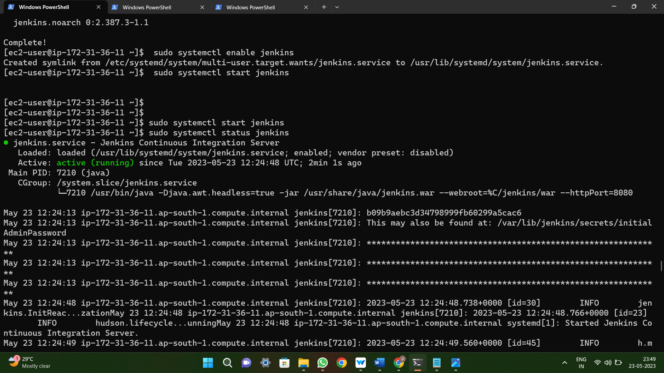

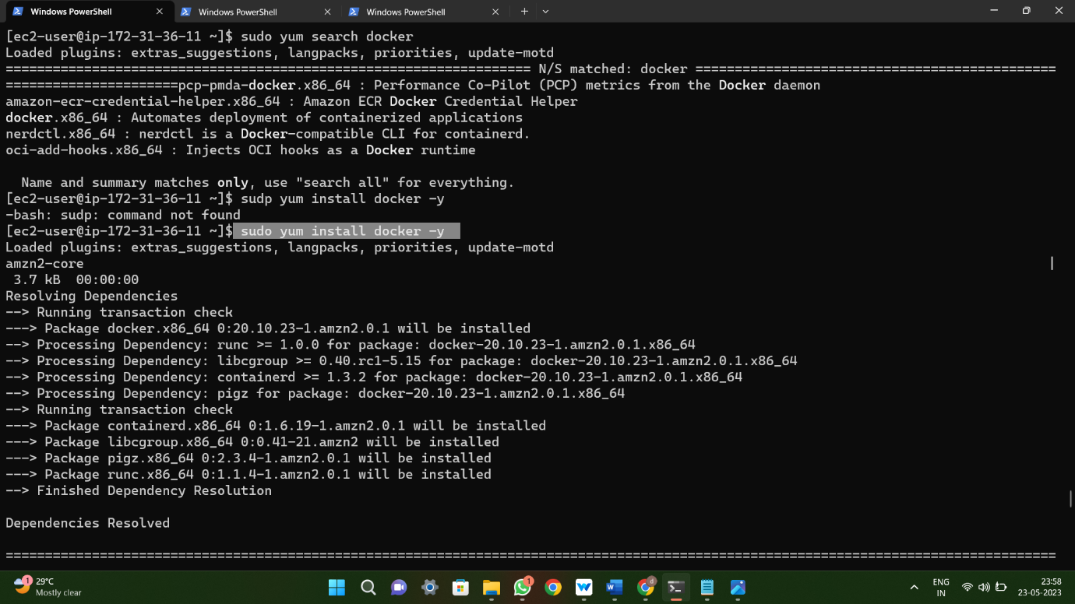

Step-2: Giving permissions to the Jenkins password **jenkins ALL=NOPASSWD:ALL** and also change **sudoers** permissions

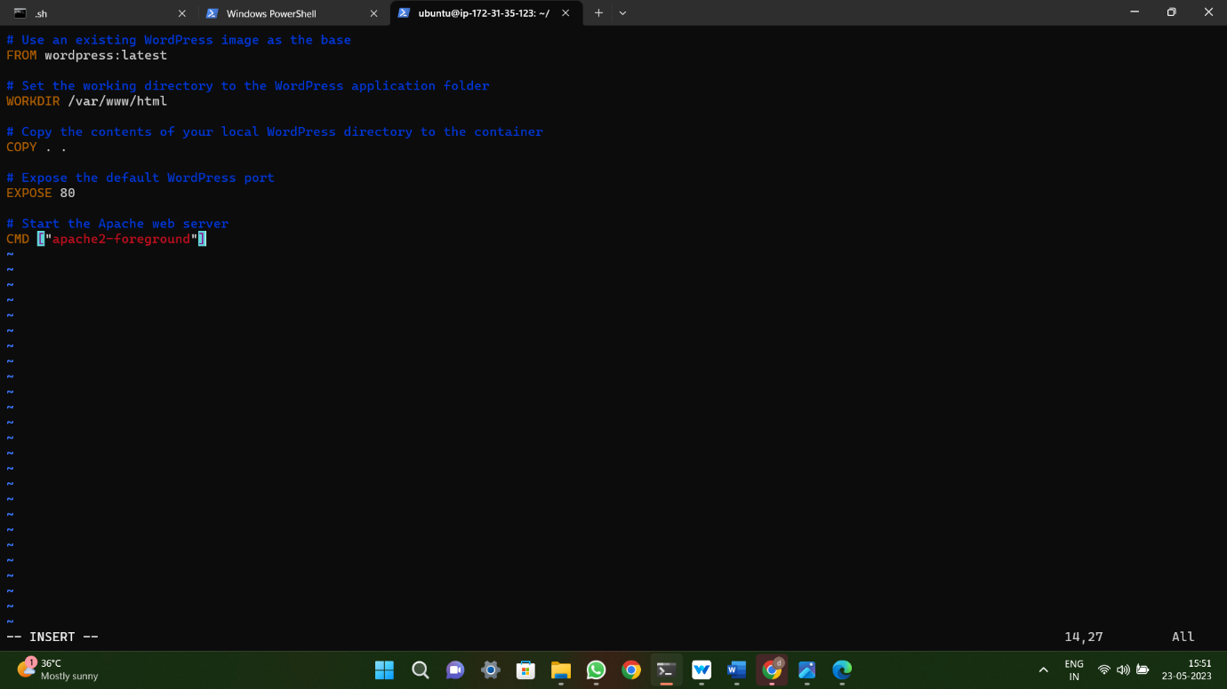

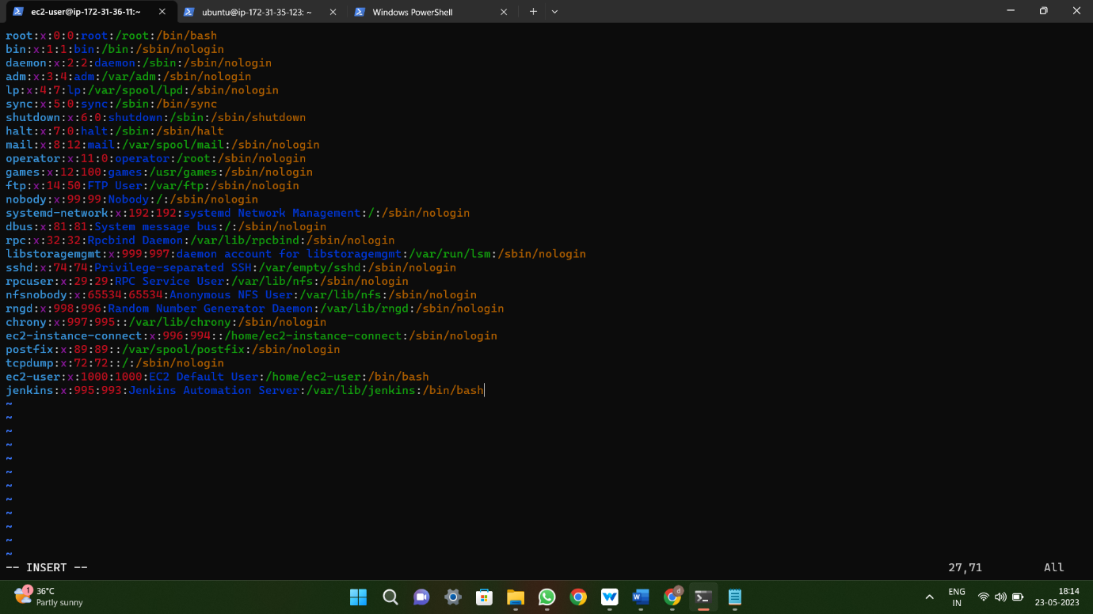

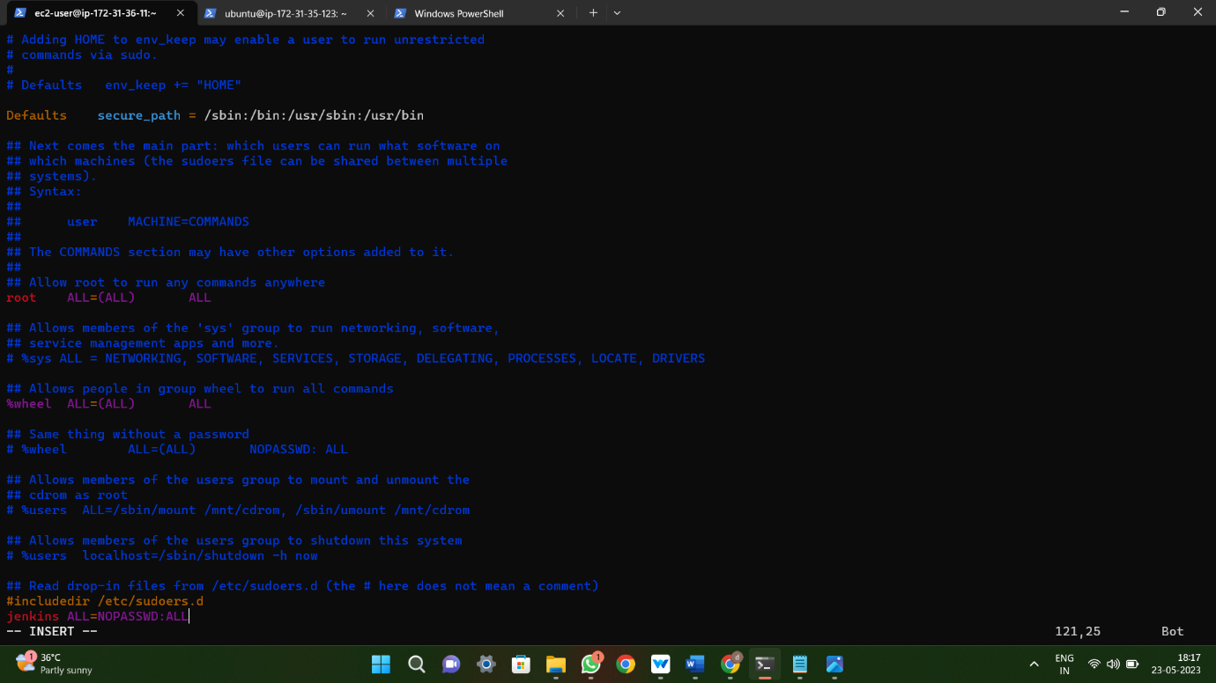

Step-3: Give the commands in **Execute Shell** and build it.

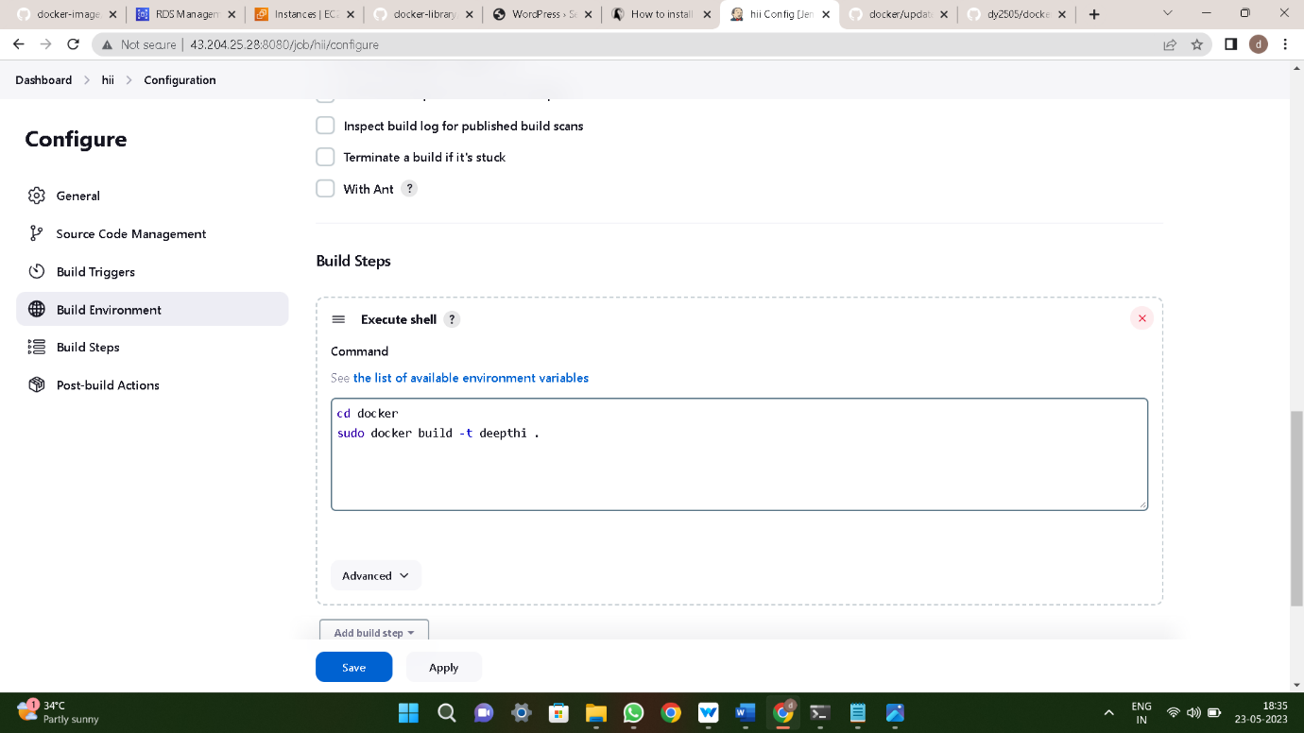

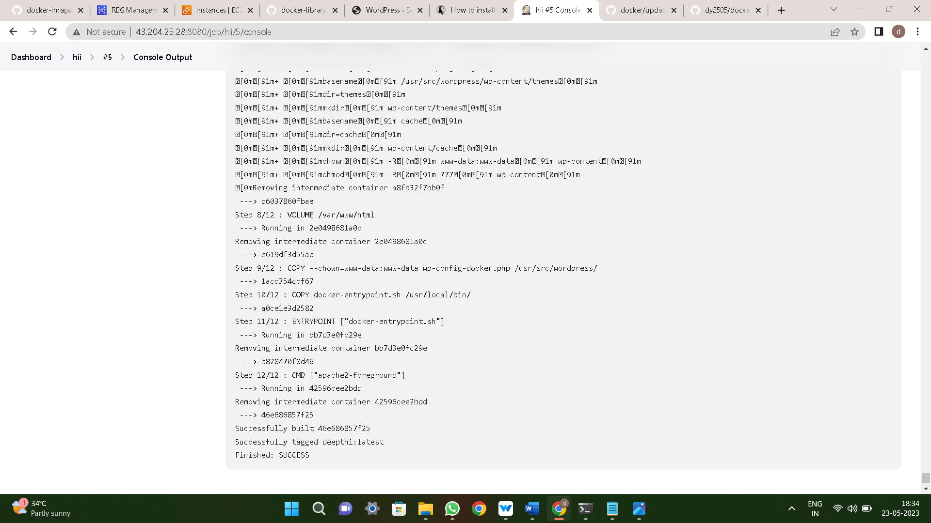

Step-4: After browse the **Public IP4** .

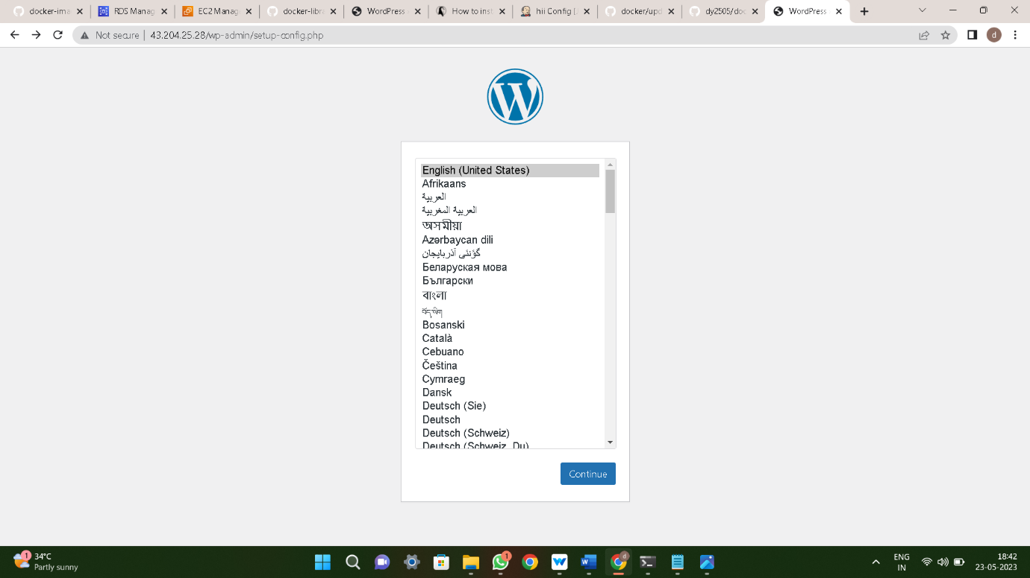

**Method-8:**

**Deploying WordPress by using Userdata.sh & Jenkins**

Step-1: Create an Ec2 instance and connect to the terminal , Install **Jenkins** & **Userdata.sh**





Step-2: Create a free trail project and give some script in the Execute shell and build it



